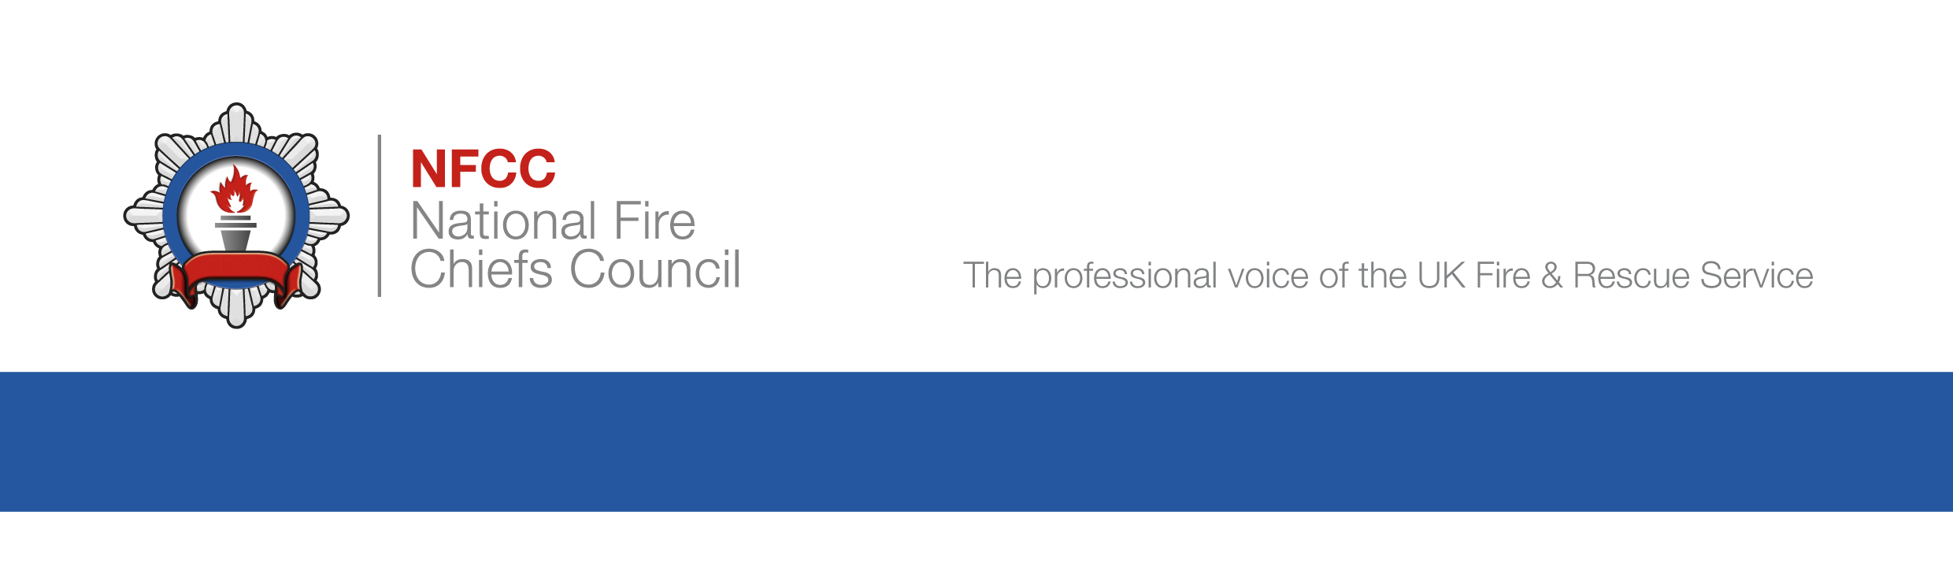

Case study

Specialised housing – Workshop Case Study
Case Study: Sheltered Housing Premises
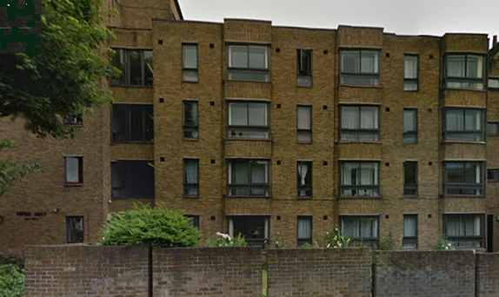

Incident
Daylight hours– Involving elderly occupier –recently diagnosed with dementia, who spoke very little English. He jumped from 3rd floor bedroom window following fire in flat, when fire occurred he was unable to communicate with provided Telecare provider in English

Background Information
The premises was built in 1977, compliant design for sheltered housing premises. It is a 4 storey building that consists of 36 flats. The flats are single bedroom properties; including separate lounge and kitchen with own cooking facilities. There is an element of care support provided for those that require it, some provided with extra care.
A telecare system is provided as standard. A Premises Information Box (PIB) is located at the main entrance; premises and individual tenant’s mobility and evacuation information is held within it and updated on a weekly basis. A scheme manager is on site during office hours Monday-Friday. Staff that are based on site are not classed as fire wardens.

This briefing note provides the necessary details needed to complete an audit on the above premises in line with the new guide.
Fire Risk Assessment

- Fire risk assessment carried out on 13/04/2016.
- The Fire risk assessment states a `Stay Put` evacuation procedure is in place, 60 minute separation between the self-contained sheltered housing flats is confirmed.
- The FRA also states the alarm fitted is configured as a Grade A LD2. This was confusing as this stated category of alarm did not relate to the L3 common parts alarm with Single Stage (Immediate) evacuation being in place.
- No fire separation survey had been carried out, however the property has no signs of compartmentation issues in the common parts
- Fire doors identified as old style fire door with ‘Perco’ closers and 25mm rebated frames. The FRA recommended upgrading of flat front doors to include current self-closing devices.
- Appropriate smoke vent provision provided for premises.
- All furnishings in common lounge comply with modern furnishing standards
- FRA did not confirm that any reports made of the dispersal and spread of cooking smells and noise from other flats however property inspection indicates no compartment issues
- The use of mobility scooters including: storage position and charging arrangements have not been considered. None currently used by tenants on the premises.
- The FRA considers that the premises are provided with reasonable arrangements for means of escape for disabled people. 2 protected staircases from upper floors and several exits from ground floor. All adequately lit and signed.
- Lift grounds in event of fire alarm actuating.
- The FRA has no details of relevant persons especially at risk in the building, No individual tenants have been identified or risk assessed.
- All staff work office hours 9-5. 4 staff members including 1 handyman are based in this building.
- Care support is provided by the local authority on an ad hoc basis. Tenants have their own self-contained individual flats with access to a communal lounge
- The FRA states that the telecare system is in all rooms.

Fire strategy and evacuation arrangements

- Stay put policy for the elderly residents is contradicted by alarm sounding throughout the premises when single stage alarm activates. During the audit staff had stated that residents often came out of their flats during weekly alarm tests. However, a fire drill has not been completed within the last 6 months.
- FRA recommended upgrading of flat front doors to include current self-closing devices.

Fire detection, alarm and Telecare system

- For the communal area a BS 5839 Part 1 L3 addressable fire alarm system is in place- interlinking smoke detectors within the lobby of the individual flats
- A BS 5839 Part 6 LD2 telecare enabled smoke detection system was provided within flats. An additional zone floor plan is displayed next to the telecare enabled smoke detection systems own control panel
- During the fire the occupier triggered a call to the call centre however the smoke alarm in the flat detected smoke but did not show as a smoke detector (as recommended in BS5839 part 6) and did not trigger the two-way speech mechanism. This resulted in a delay from the telecare operator alerting the fire brigade
- Prior to the UWFS policy, false alarm calls to the fire service were high. Management system for false alarms now in place: calls to fire service in last 12 months count = 2 calls
- A Telecare intercom system provides access around the building; this is linked to the fire alarm system and an ARC. It was found that the system fitted was connected to the Telecare system with only one phone line provided between the occupier and telecare provider when the fire alarm system activated.
- No maintenance records were available
- No information available for the installation, commissioning, service and maintenance certificates for the fire detection and alarm systems in the communal areas
- No cause and effect records could be provided
- No evidence available to ensure reliable alarm transmission of both pendants and the Telecare enabled alarm system when operated in the flats.
- The communal fire detection and fire alarm system is integrated with the flat Telecare enabled systems, communications link not assured
- The fire alarm signals from dwelling units are indicated on a separate on-site fire alarm control panel
- The fire alarm monitoring company is third party certificated to BS5979 or BS8591 or accredited with the Telecare Services Association code of practice.
- Service records were available for communal alarm system, not available for Telecare enable alarm.

Emergency Lighting, Fire Exit Signage, Fire Fighting equipment

- Fire Exit directional signage is displayed. Fire Action Notices, No Smoking signage, Push Bar To Open signage
- Various fire extinguishers are installed throughout the communal areas. A fire blanket is installed within the communal lounge kitchenette. These were last serviced July 2015.
- All fire safety provisions under regular maintenance contracts - The alarm system is tested weekly and serviced yearly. EL (installed throughout), FFE, fire lift and AOVs all serviced and records seen

Reduce Risks

- Residents who smoke have not been identified
- A Premises Information Box (PIB) is located at the main entrance; premises and individual tenant’s mobility and evacuation information is held within and updated on a weekly basis
- FRA had not considered or recommend appropriate use of sprinklers.

