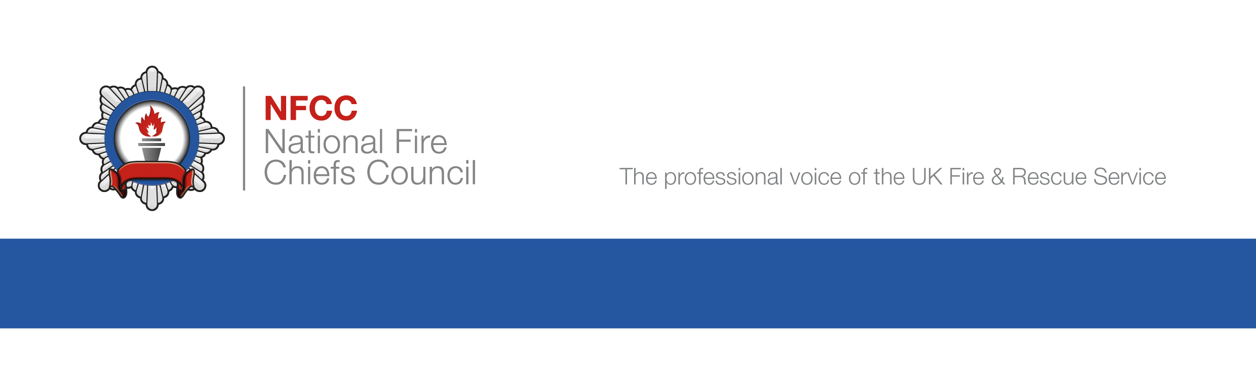

Case study

Specialised housing – Workshop Case Study
Case Study: Supported Housing
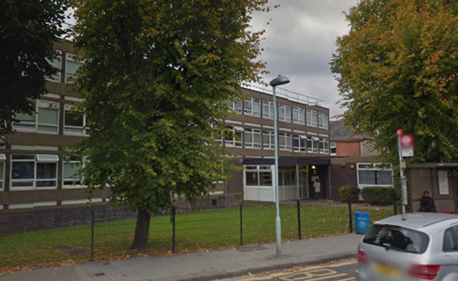

Background information

Premises is a purpose built supported housing unit for adults with drug and alcohol issues. 4 storey building with 29 individual studio type dwellings each with their own cooking facilities, plant / electrical rooms only in the basement floor. Floor area 750 m2 per floor. Also used for care for adults with mental health issues prior to moving back into the community. Only a few longer term (2 years plus) residents. Access to all rooms for staff members.

Fire risk assessment

- Staff instructed to investigate any fire alarm actuation and if there are signs of fire such as smoke or excessive heat then return to the assembly point and contact 999. All tenants are able to self-evacuate in the event of the fire alarm actuating. Single stage evacuation of premises on actuation of fire alarm.
- No mention in fire risk assessment (FRA) of compartmentation survey.
- Fire risk assessment makes no mention of fire hazards in relation to individual tenants.
- Customer Room Checks are carried out at least every month, or sooner depending on customer need. No further details recorded.
- No mention of mobility scooters. Currently not in use in the premises.
- No mention of Telecare.

Fire strategy and evacuation arrangements

- 29 tenants. 2 staff sleep over rooms. Staff on site 24/7. Single stage evacuation of premises on actuation of fire alarm.
- Recent rewiring of the premises has left gaps around new wiring through compartment walls. All fire doors self-close effectively and fitted with cold smoke seals and intumescent strips.
- Residents take part in quarterly fire drill and are made aware of fire evacuation strategy on arrival at the hostel. Suitable responses received from 2 residents when questioned by IO.
- All means of escape are clear and available. All final exit doors available and opened without difficulty.

Fire detection and alarm system

- A BS 5839-1 Category L2 fire alarm and detection system is in place. Each tenant’s room has heat detector linked to main fire alarm as well standalone mains powered (with battery back-up) smoke detector for early warning of the tenant. Had previously been a series of UWFS when multipoint optical / heat detection was installed in the tenants’ rooms linked to the main alarm system.
- Fire alarm serviced by competent engineer regularly and testing is in accordance with current British Standard.
- No Telecare provision at this time.

Staff training

- Staff training carried out every six months, fire marshalls appointed and fire drills carried out quarterly.
- Fire alarm zone maps in place adjacent to fire alarm panel and in line with staff understanding of what different zones are called. Confirmed through questioning 2 staff members.

Emergency Lighting, Fire Exit Signage, Fire Fighting equipment

- Fire fighting equipment appropriate for the premises has been installed and serviced by competent person annually.
- Emergency lighting provided to BS 5266 and serviced by competent person on 09/12/15 and testing is in accordance with current British Standard.
- Appropriate fire exit signage in place.

Reduce risks

- No smoking policy within the premises. Designated under cover smoking area outside the building. Staff clear on the policy. No individual smoking risk assessments for residents who do smoke.
- Staff aware of one resident who has hoarding behaviour. Discussion confirms that hoarding is level 5. Resident is a smoker and staff have seen signs of careless disposal of smoking materials (burns on carpet in his studio type dwelling).

