**Module Overview:**





1. Undertaking Equality Impact Assessments (EqIAs) - which effectively analyse policies / activities and their potential impact on people, are important to the NFCC in that they:

2. Help us in realising at least two of our overall strategic commitments: ***Reducing***

***Community Risk & Vulnerability*** and to be ***Focused on People***.

3. Assist us in realising one of our major overall aims which is to ***work collaboratively with***

***fire and rescue services - promoting national approaches where they work best.***

4. Allow us to consider our own internal activities and how we could be more inclusive.

5. Effective completion of EqIA are also a critical consideration within all UK fire and rescue services for five key reasons:

6. **To meet both legal and statutory obligations** in promoting equality of access and

opportunity and avoiding discrimination. (See appendix of this module).

7. **To meet any agreed Equality commitments you may have made** within your

individual services to Equality. This applies in respect of both employment and fire

and rescue activities. These commitments are typically detailed within your own service

equality policies.

8. **Many forms of disadvantage or discrimination can be unintentional, indirect or**

**even hidden within service activities** i.e. they are not always immediately obvious or

easy to recognise. Undertaking EqIAs allow you to identify any

potential risks and agree the actions you may take to remove or reduce these risks.

9. **External scrutiny**. *Her Majesty’s Inspectorate of Constabulary and Fire & Rescue*

*Services (HMICFRS)* who independently assesses and reports on the effectiveness and

efficiency of fire & rescue services (in the public interest) routinely assesses approaches

to how individual services **‘Ensure Fairness and Diversity**.’ (Currently a key HMICFRS

assessment question as part of the *‘How well does the fire and rescue service look after its people ?*

*inspection criteria. (Source HMICFRS October 2021.)*

10. The NFCC unreservedly advocates it is the **right thing to do to ensure services are**

**providing modern and inclusive approaches fit for the 2020’s.**

11. This module details exactly how and why an Equality Impact Assessment should be completed. It includes tools, techniques, examples of exemplar practice and external resources and reference points.

**12. Module Contents:**

*What is an EqIA?*

*Benefits of Undertaking an EqIA*

*When is an EqIA required ?*

*Initial Screening and Full EqIA*

*Five Stage Approach to EqIAs*

*Legal and Statutory Requirements*

*Tools for Effective Completion*

**13.** **What is an Equality Impact Assessment?**

14. An Equality Impact Assessment is effectively a **risk assessment**. It’s overall aim is to identify **risk** of inequality, discrimination or disadvantage within service activities (or proposed activities) by assessing the likely impact your policies, procedures, projects or functions might have on the different groups of people you both serve and employ.

15. This includes residents, community groups, employees and other members of the public who may be affected by your activities.

Example:

*16. A service has a policy of leaving all appliance’s blue lights switched on when*

*attending incidents – including residential dwelling fires.*

*17. This policy applies equally to all incidents and people. However, on balance,*

*there is a* ***risk*** *that this policy could adversely affect* ***certain groups of***

***people differently****. For example, people with certain neuro diverse conditions –*

*including autism and epilepsy who may be extremely sensitive to sounds, sights, or*

*smells – similar to a condition known as sensory processing disorder.*

*18. The service has never previously considered how this policy may impact on neuro*

*diverse groups and completing an Equality impact Assessment allows the undertaking*

*of external research and consultation which ultimately leads to a revision of this policy.*

**19.** **Benefits of Undertaking an Equality Impact Assessment**

20. There are numerous benefits of undertaking an Equality Impact Assessment (EqIA). These include:

* Identifying and meeting the needs of our diverse residents and employees.
* Designing inclusive services and facilities.
* Avoiding discrimination and disadvantage.
* Embedding Equality and Inclusion in all of our activities and bringing our Equality policies to ‘life’.
* Meeting our legal and statutory duties in this area.
* Proactively identifying potential discrimination rather than it being brought to our attention by our residents or employees.
* Improved decision making.
* Improved procurement and commissioning of services.



**Key Points:**

Key Point

**21. Promoting Equality of opportunity and access does not mean**

**treating people equally. We may sometimes do different things**

**to meet the needs of different groups of people.**

**22.** **When is an Equality Impact Assessment (EqIA) required?**

23. An Equality Impact Assessment is required for the majority of service and employment activities - this includes:

Example Initial Screening Tool:

East Sussex Fire and Rescue Service

**24.** **Initial Screening or Full Assessment ?**

25. Some services use a short *Initial Screening* tool in the first instance, to make a preliminary assessment of an activity. The aim of an *Initial Screening* tool is to:

* Establish if, on balance, any Equality risks exist.
* Ascertain if any risks identified are capable of being

objectively justified.

* Decide if any further research and a full, more

detailed EqIA is required.

26. The decision as to whether you use an Initial Screening tool is

entirely yours. An example screening template is available within

the resources section of this module.

**27.** **NFCC Five Stage Approach to Undertaking Equality Impact**

**Assessments (EqIAs)**

28. In this section of the module, we will detail a five stage structured approach to undertaking EqIA (summarised below).

29. Each stage is explored, in greater detail within the following sections of this module.

**30 Defining the Aims of An Activity:**

31. Before commencing an Equality Impact Assessment, it is essential that you establish and understand the answers to the following questions:

***1: Why does the policy, activity or function exist within our service ?***

***2: What are the legitimate aims i.e. what is it aiming to achieve ?***

***3: Can we objectively justify implementing activities which may, on balance,***

***discriminate against certain sections of society ?***

**32. Examples of Defining Aims and Justifying Discrimination**:

|  |  |  |
| --- | --- | --- |
| **A33. ctivity:** | **34. Summary of Aims:** | **35. Potential Equality Risks:** |
| FRS Cadets Scheme | Provide opportunities for people aged 13 – 17 to gain fire and rescue service experience. | Age discrimination.  The negative impact on other age groups **is capable of being justified** as the scheme is designed to benefit young people. |
| Policy requiring fire fighters to be clean shaven | Allow breathing apparatus to fit correctly. | Will generally only apply to men and may disadvantage men from certain religions who do not shave e.g. Sikh.  This negative impact is **capable of being justified** on the grounds of health and safety. |
| Implementing a compulsory practical swimming test for fire fighters. | Ensure all fire fighters can deal with water based rescue incidents. | May discriminate against people from certain ethnicities who for cultural reasons, may not have learnt to swim and people with certain disabilities.  This negative impact may **not be justified** and a full EqIA and further research and consultation is required. |

**36. Assessing Risks – Direct and Indirect:**

37. Equality risks can be both directly and indirectly discriminatory. This part of the module examines the difference between the two.

**38. Definitions of *Direct* and *Indirect* Discrimination:**

**39. Direct Discrimination:**

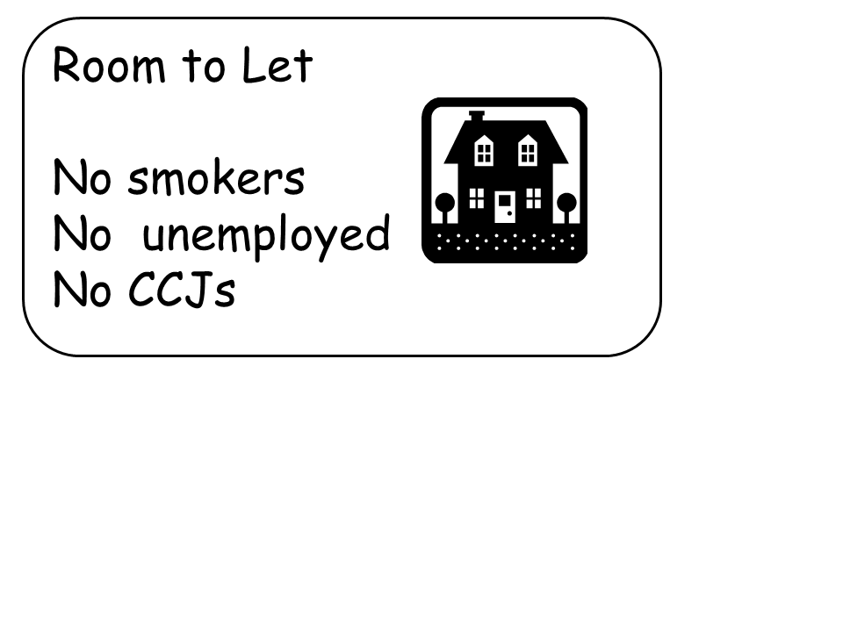

*40. Direct discrimination* is often both overt and obvious and excludes

or discriminates against different sections of the community.

41. Where you identify *Direct Discrimination* as part of an EqIA, you

should consider the following three key questions:

**1**: 42. **Is this discrimination capable of being objectively justified based on the overall aims of the policy / activity ? (Please see previous section.)**

**2: 43. Does the direct discrimination affect any of the groups of people listed within the NFCC EqIA template and is therefore unlawful ?** (*Sex, Race, Disability, Religion, Sexual*

*Orientation, Age, Marriage / Civil Partnerships, Pregnancy / Maternity or Transgender)..*

**3: 44. Could we reduce or remove the discrimination by changing our approaches ?**

**Example:**

*45. A service has a policy of undertaking ‘Safe and Well’ visits with residents who*

*are over 65. You undertake an Initial Screening of this policy and identify* ***Direct***

***Age Discrimination*** *in that people under 65 are not entitled to such visits.*

*46. Using the three key questions above, you identify the following:*

*47. The policy exists as part of the service’s support to older residents who, on balance,*

*have higher fire risks. This is also supported by local fire incident data.*

*48. The policy directly discriminates against younger residents. ‘Age’ is one of nine*

*characteristics protected by The Equality Act 2010 and this discrimination is therefore*

*at risk of being unlawful.*

*49. Undertaking ‘Safe and Well visits’ with all residents would be logistical impossible but the risk is mitigated by including both disabled residents and other groups you identify*

*as being vulnerable – again using local and national fire research information.*



**50. Assessing Risks – Direct and Indirect: (continued)**

**Indirect Discrimination:**

51. This can often be slightly more complicated in that unlike *Direct* discrimination, *Indirect discrimination* is often not obvious, overt and may be unintentional. It is important to note that unintentional or even accidental discrimination may *explain* but does not *excuse* unlawful discrimination in the eyes of the law.

Example:

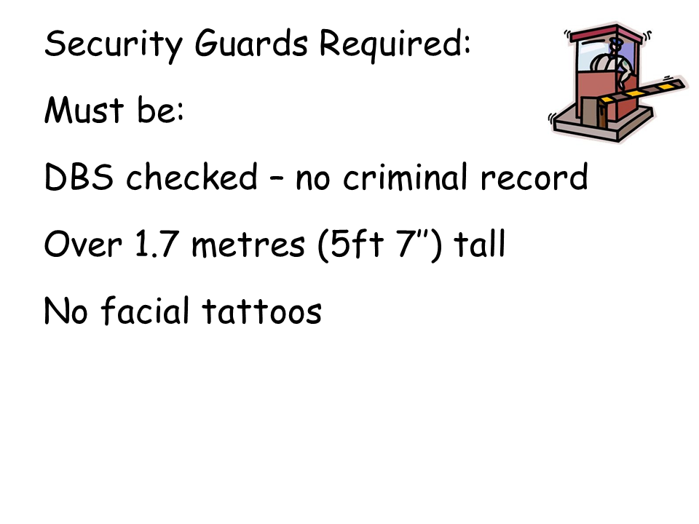

***52. A service advertises for internal security***

***staff by placing the advert shown opposite:***

***53. You undertake an initial screening on the***

***job adverts using the three key questions***

***listed overleaf. You conclude:***

*1: 54. The overall aim of the activity is to recruit security staff to protect service buildings and facilities which is a legitimate function. The job description stipulates a height restriction of 1.7 metres. A key requirement of the role is to have an ‘authoritative presence’.*

*2: 55. The policy directly discriminates against people with a criminal record, smaller people and tattooed people. None of these characteristics are either protected by The Equality Act 2010 or listed within the NFCC’s EqIA documents.*

*3: 56. The job specification stipulates a height restriction and there is a genuine reason for*

*including this in the job advert. At this stage, a fourth and very important question is required….*

4: 57. **Is there a risk that this activity could disproportionality impact on certain groups of people ?** Particularly the groups listed on the NFCC EqIA document. (In this context, ‘disproportionate’ means that on balance, some groups of people would have greater difficulty complying with the stipulated requirements than others.)

58. In answer to question four above, **what would you recommend as part of your Initial Screening ?** An example answer is provided below.

59. This height restriction stipulated in this job advert presents a risk of Indirect Discrimination towards both **Women** and people drawn from certain **Ethnicities** who on balance, may be less likely to meet this height requirement. A full Equality Analysis is required which should include an objective review of the job description to establish if people who are less than 1.7 metres tall could reasonably undertake this role. The indirect discrimination identified is potentially unlawful so the job advert should be removed until further research is complete.

**60. Treating Identified Risks:**

61. If you identify any potential equality risks when undertaking an EqIA, you are ultimately required to consider one of three different actions. These are:

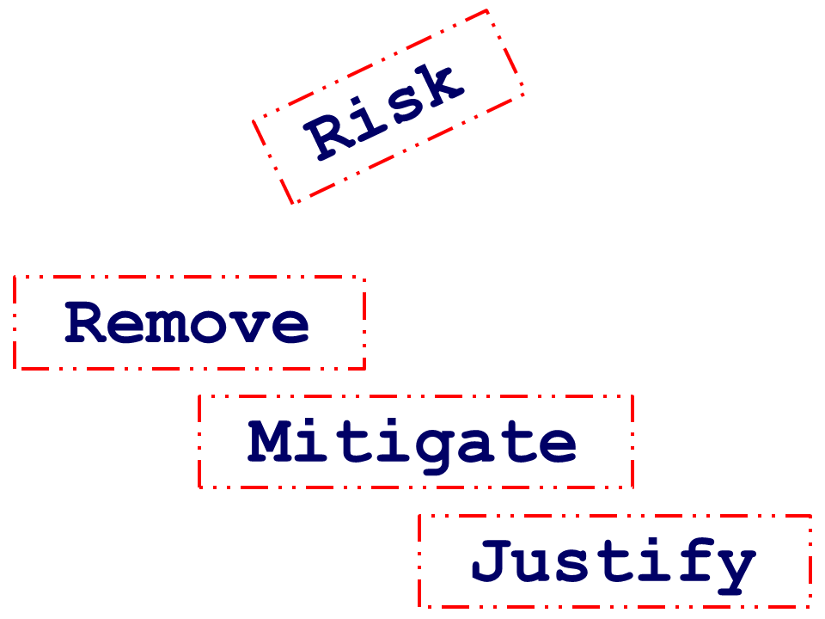

1: 62. **Remove the risk** by discontinuing the policy or activity.

2: 63. **Mitigate or reduce** the risk by amending the policy or activity.

3: 64. **Justify the discrimination**. As previously stated, in certain

circumstances, the service may genuinely be required to treat

different groups of people in different ways to deliver a service

which can be objectively justified.

**65. Treating Equality Risks – Example:**

*66. A service has a cadets policy that prohibits all cadets from wearing any form of*

*jewellery for health and safety reasons. You undertake an initial review / screening of*

*this policy and identify at least two potential risks of inequality:*

***1: 67. Gender.*** *On balance, more female cadets may wear*

*jewellery compared to males.*

***2: 68. Religion.*** *Certain religions – for example, Sikhs are*

*required to wear a bangle as part of their faith. Christian*

*cadets may also wish to wear a cross.*

*69. You undertake a more detailed EqIA of this policy using information and research and ultimately recommend:*

*1: 70. The policy should not be removed completely as there are legitimate reasons for its existence and implementation.*

*2: 71. Any discrimination against people of different religions / faiths cannot be objectively justified as the policy could easily be modified to reduce this risk.*

*3: 72. The policy should therefore be amended to state that whilst most Jewellery is*

*forbidden, e.g. rings, ear rings, nose rings etc. Jewellery that is directly related to an*

*established faith group may be worn by both male or female cadets.*

Risk Mitigated

**73. Accessibility:**

74. An EqIA requires you to consider how accessible an activity, policy or function is:

**75. Physical Access to Services:**

76. You should be able to demonstrate that your service has taken all reasonable steps to ensure that a policy, service, function or activity is physically accessible. This should be in respect of employees and service users that have any physical limitations or impairments. This should include buildings and premises and accessibility of information in different formats / fonts etc.

**77. Digital Exclusion:**

78. Where services or information are provided digitally, you should also consider non digital options for people who do not use, or cannot access, by electronic means.

**79. Language:**

80. Consider if any key written information is available (or easily translated) into the principal languages spoken within the communities served by your service.

**81. Non Visible Disabilities:**

82. You should consider how the activity being assessed impacts on all types of disabilities – including neuro diverse conditions and learning disabilities.

**83. Profiling Information:**

84. Where an EqIA identifies potential Equality risks, data is generally required to support your conclusion.

85. It is important to use recent and accurate data when completing an EqIA. Data used can often be a combination of *Quantitative*, *Qualitative* or *Service* data.

**86. Common Types of Data Used:**

***87. Quantitative data*** refers to numbers / metrics and can include demographic information about employees and communities. Both the *Office for National Statistics* ([www.ons.gov.uk](http://www.ons.gov.uk)) and partner organisations (especially your local authority) may have data to support your analysis.

***88. Qualitative data*** refers to the experience of individuals (or groups) from their own perspectives. This type of data is most commonly collected via either consultations, focus groups, review of complaints made, user feedback or interviews.

***89. Service data*** is also a valuable evidence source when carrying out an EqIA and can provide an insight into the profile of people who utilise the service or activity being assessed. For example, fire data, data collected at incidents etc.



**90. Key Point:**

Key Point

**91. You should always aim to evidence references to data where possible,**

**by including links to the source of the data.**



**92. Consultation:**

**93. Consultation, as part of an Equality analysis is typically be drawn from one of three sources:**

* 94. Existing data extracted from staff and service users. (E.g. incidents, safe and well visits, staff surveys etc.)
* 95. Data metrics (see previous section) paying particular attention to disproportionality in access and outcomes. For example, job applicant success rates by *Sex, Ethnicity and Age.*
* 96. Targeted bespoke employee or community consultation for specific projects.

**97. You may also use national research and consultation from sources such as:**

* 98. The *Office for National Statistics* – particularly for socio and economic and employment related Equality Analysis.
* *99. The Equality and Human Rights Commission*.
* *100. The Government Equalities Office.*
* 101. 3rd Sector agencies e.g. *Citizens Advice*.



**102. Top Tip:**

**103. You may find it useful to review any Equality Analysis reports already undertaken and published (via the web) on similar policies or functions by other organisations – particularly other UK Fire and Rescue Services.**

104. The intention is not to *copy* what other people have done. You may however draw both inspiration and ideas from external sources !

**105. Full Equality Impact Assessment:**

Extract: NFCC Full EqIA Template. The full template is available by clicking on the link provided within the resources section

106. A full EqIA is completed using the NFCC template and should contain at least the following key elements:

Checklist of the key elements of an EqiA



**107. Full Equality Impact Assessment: (continued)**

108. An EqIA should be a detailed and comprehensive assessment of an activity. It should not generally contain one line summaries. If a risk of ‘nil impact’ is recorded, you should state why. For example:

*109. Whilst there is currently no evidence to suggest that female employees are placed at a disadvantage compared to their male counterparts (or vice versa), it is recommended that an analysis, by Sex, be performed by H.R. of the ‘lifecycle’ of employees accessing this activity to identify if any adverse trends (e.g. success rates) exists between male and female firefighters.*

**110. Examples of Completed EqIAs**

111. Links to examples of completed EqIAs can be found within the resources section of this module.

**112. Full Equality Impact Assessment: (continued)**

**113. Smart Questioning Tools:**

114. You may find the list of examples questions to be useful when completing an EqIA.



**115. Full Equality Impact Assessment: (continued)**

**116. SMART Action Planning:**

117. Please ensure that any actions listed at the end of your EqIA meet the basic SMART test in that they are

* Specific
* Measurable
* Achievable
* Realistic
* Time Bound

118. They should also list:

* The person responsible for the action
* A review date



**119.** **Legal And Statutory Requirements**

***120. The Equality Act 2010:***

121. An Equality Impact Assessment must reference *The Equality Act 2010* which protects people against discrimination on the ground of:

* Sex
* Race
* Disability
* Age
* Sexual Orientation
* Religion / Belief
* Marriage and Civil Partnerships
* Pregnancy and Maternity
* Transgender

**122. The Public Sector Equality Duty**

123. Requires all Fire and Rescue Services to have 'due regard' to the need to:

* 124. Eliminate unlawful discrimination, harassment, victimisation and any other conduct prohibited by the Equality Act.
* 125. Advance equality of opportunity between people who share a protected characteristic and people who do not share it; and
* 126. Foster good relations between people who share a protected characteristic and those who do not share it.

127. Completing EqIAs allows you to analyse and record how your service has applied this 'due regard' when considering changes to activities, services, functions or policies.

128. Having due regard for advancing equality involves **proactively:**

* 129. Removing or minimising disadvantages suffered by people due to their protected characteristics.
* 130. Taking steps to meet the needs of people from protected groups where these are different from the needs of other people.
* 131. Encouraging people from protected groups to participate in public life or in other activities where their participation is disproportionately low.



**132. Legal Definitions of *Direct* and *Indirect* Discrimination:**



**133. Key Points:**

Key Points

***134. Direct Discrimination*** is legally defined as:

**135. Where a person is treated less favourably than another person on**

**the grounds of a ‘*Protected Characteristic’.***

***136. Indirect Discrimination*** is defined as:

**137. When you apply a provision, criterion or practice in the same way for all people, but this has the effect of placing a group (or groups) who have protected**

**characteristics, at a particular disadvantage**



**138.** **Tools, Resources and Downloads**

*139. NFCC EqIA Template* [to be added]

140. The latest EqIA template documentation can be found here

*141. NFCC EqIA Initial Screening Tool* [to be added]

142. One page screening tool

*143. NFCC EqIA Guidance Notes* [to be added]

144. A PDF version of this module for download [to be added]

*145.* [*EHRC Technical Guidance*](https://www.equalityhumanrights.com/en/advice-and-guidance/equality-act-technical-guidance)

146. Further technical guidance on producing EqIAs published by the Equality and Human

Rights Commission (England and Wales) Advanced users only

*148.* [*EHRC Equality Information Guidance*](https://www.equalityhumanrights.com/en/advice-and-guidance/equality-act-guidance)

149. Further technical guidance on collecting Equality profiling information for public bodies.

End of document. All rights (including intellectual) are © 2021 National Fire Chiefs Council