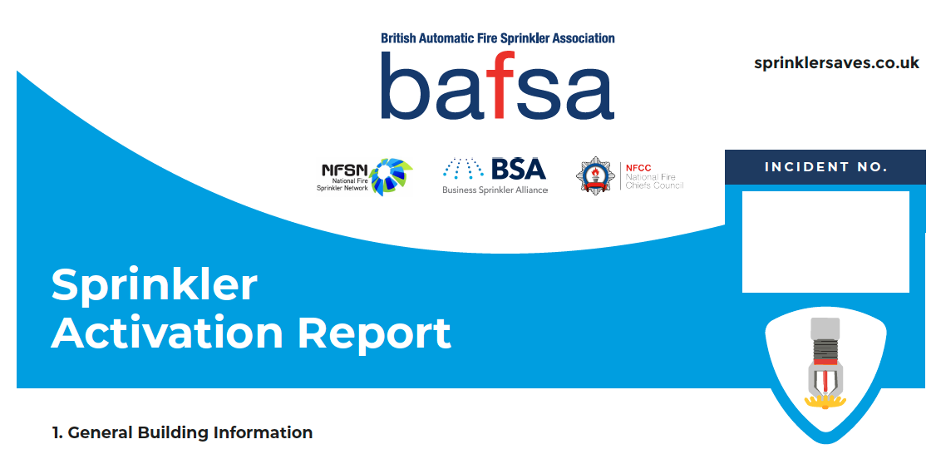

ADDRESS/NAME OF BUILDING

FIRE SERV ICE C ONTA C T

P ROP ER T Y O W NER DETAIL S

MOBILE NUMBER

T Y P E OF BUILDING HEIGHT OF BUILDINGS (S T ORE Y S)

Choose an item.
Choose an item.

2. Incident Information
FIRE & SERV ICE RESC UE

D ATE OF INCIDENT TIME OF C ALL
Click here to enter a date.

EMAIL ADDRESS

DESCRIP TION AND SIZE OF P REMISES

L OC ATION OF INCIDENT

T Y P E OF WATER SUP P LY
Choose an item.

MATERIAL IGNITED FIRS T

T O TAL P ROP ER T Y AREA D AMA GED B Y FIRE (M²) FIREFIGHTING A C TION

P UMP ING/ AERIAL AP P LIANCES DEP L O Y ED AT TIME OF S T OP

3.Sprinkler System Information

T Y P E OF SP RINKLER INS TALL ATION T Y PE OF NO ZZLE HEAD N U M B E R OF HEADS OPERATED
Choose an item.
Choose an item.
Choose an item.

W HAT P RO V ISIONS W ERE P RO V IDED ON SITE ALL O W ING THE SP RINKLER S Y S TEM T O RAISE THE AL ARM?
choose an item

4.Business Continuity, Effects of Incident

BUSINESS INTERRUP TION
Choose an item.

OC C UPANY FIGURE IN BUILDING AT TIME OF INCIDENT
Choose an item.

ES TIMATED VAL UE OF D AMA GE
Choose an item.

ADDITIONAL INF ORMATION

