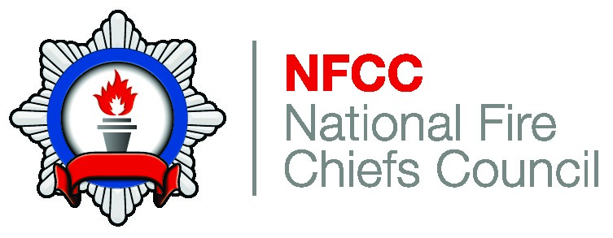
The National Coordination and
Advisory Framework (NCAF) England

Sept 2021

© Crown copyright 2019
This publication is licensed under the terms of the Open Government Licence v3.0 except where otherwise stated. To view this licence, visit nationalarchives.gov.uk/doc/opengovernment-licence/version/3

Where we have identified any third party copyright information you will need to obtain permission from the copyright holders concerned.

This publication is available at www.gov.uk/government/publications

Any enquiries regarding this publication should be sent to us at

NationalResilienceandFireProgrammes@homeoffice.gov.uk

Contents
Foreword 5
1. Introduction 6
2. Emergency Response 8
Fire & Rescue Services (FRSs) 8
Home Office (HO) 8
3. Functions 10
Mobilisation, Co-ordination and Monitoring of National Resilience Assets 10
Multi Agency/Strategic Holding Areas (MA/SHAs) 10
CPFG & Homeland Security Operations Centres 10
Home Office Operations Centres 10
Cabinet Office Briefing Rooms (COBR) 10
4. Roles 11
National Resilience Fire Control (NRFC) 11
Tactical Advisor (TacAd) 11
National Resilience Assurance Team (NRAT) & Duty Officer 11
Home Office Fire Duty Officer 11
National Strategic Assurance Team (NSAT) 11
Chair of the National Fire Chiefs Council (NFCC) 12
5. Capabilities 13
6. NCAF in Operation 14
7. Resource Deployment and Cost Recovery 15
Pre-deployments 15
Post-occurrence 15
Cost Recovery 15
8. International Reciprocal Mutual Assistance 16
Incoming: International Reciprocal Mutual Assistance 16
Outgoing: International Reciprocal Mutual Assistance 16
9. Annex A: Central Government’s response to major incidents 17
Concept of Operations for CPFG Critical Incident Management Response 17
Purpose 17
Who is this document for? 17
What do we mean by a ‘critical incident’? 18
What will CPFG have to do during a critical incident? 19
How will CPFG deliver its response to a critical incident? 19
Resourcing a critical incident 20
Homeland Security Operations Centre 20
10. Annex B International Reciprocal Mutual Assistance 22
Incoming: International Mutual Assistance 22
11. NFCC National Crisis Plan Management 23
12. Bibliography 24
13. Glossary 25

Foreword
The environment in which fire and rescue services operate is often complex and challenging. The experiences of the Grenfell Tower fire, Westminster Bridge and London Bridge terror attacks in 2017, the 2015–16 winter floods in Cumbria, Yorkshire & Lancashire, the Didcot power station collapse (2016) and the Bosley Mill wood flour mill explosion (2015) clearly illustrate the diverse nature of these challenges and demonstrated the professionalism of our fire and rescue services when responding to major incidents.
Major incidents of this nature invariably occur over prolonged periods of time and place significant demands on local fire and rescue services (FRSs). Therefore, it is essential that we have robust levels of preparedness and response in place to assist our fire and rescue services in the safe resolution of a major incident. To enable this, we have secured the provision of effective and efficient specialist national resilience capabilities, advice, and national guidance.
When considering major incidents it is important for us to recognise that the response and recovery arrangements to a major incident are provided by a wide range of local and national services and agencies.
It is for these reasons that the National Coordination and Advisory Framework (NCAF) has been designed to provide robust and flexible response arrangements to emergencies that can be adapted to the nature, scale and requirements of the incident. The framework will also support communities affected by emergencies to be returned to normality as quickly as possible whilst affording a valuable interface between local and central government.
This guidance has been developed jointly between the National Fire Chiefs Council (NFCC) and the Home Office (HO). I am confident the framework will provide the necessary advice and guidance to fire and rescue services which will deliver the effective coordination of resources before, during and after major incidents. Furthermore, it sets out the critical situational awareness reporting arrangements which will facilitate central government’s decision making that is designed to protect and reassure local communities during emergencies.

Nick Hurd
Minister of State for Policing and the Fire Service

Introduction

The NCAF has been designed to provide robust and flexible response arrangements to major and large scale emergencies that can be adapted to the nature, scale and requirements of the incident. Fire and Rescue Services (FRS) must proactively engage with, and support, the NCAF arrangements including the NFCC lead operational role (Fire & Rescue Service National Framework).

Most incidents to which Fire & Rescue Services (FRS) respond are dealt with using the assets that a FRS has at its immediate disposal. However, there may be times when a FRS require specialist resources and equipment, or extra resources and assistance to deliver an effective response. An example would be a declared major incident which is defined as “an event or situation with a range of serious consequences which requires special arrangements to be implemented by one or more emergency responder agencies.” (JESIP Doctrine)

Home Office is the lead government department for Fire and will work with other government departments, partner organisations, and the Devolved Administrations during major emergencies to coordinate the deployment arrangements for Fire and Rescue assets.

The NCAF is part of the mechanism that coordinates fire & rescue assets. HO Crime Police & Fire Group (CPFG) and Homeland Security will work with other government departments, partner organisations and the devolved administrations during “no notice” and “rising tide” events to provide policy reach back and advice, ministerial briefings, co-ordination across government and management of communications. NCAF enables decision makers, both locally and nationally, to receive clear and unambiguous operational advice on how best to co-ordinate the fire & rescue service response to relevant emergencies.

NCAF supports:
- Everyday assistance and collaboration between FRSs where specialist national resilience capabilities can support the resolution of an incident
- The provision of specialist assistance to FRS where an incident warrants it and it is available from elsewhere, or additional resources where the resolution of an incident is, or is likely to be, beyond a service’s own resources or capabilities
- The coordination of the combined FRS response to relevant incidents, and when required, the integration of other first responders, for example police, ambulance and the military, at any geographical scale

The Chair of the NFCC and/or the National Strategic Advisory Team (NSAT), who by exception will deputise for the Chair of the NFCC, will provide the Home Secretary and other ministers within the Cabinet Office Briefing Rooms (COBR), with expert timely advice in accordance with central government’s requirements. Further explanation of this requirement is set out within the Fire & Rescue Service Supporting Guidance to NCAF.

The National Resilience Assurance Team (NRAT) Duty Officer supports the provision of information between the affected services, the NFCC, other agencies and government to enable the framework to operate effectively.

The framework details the functions, roles and responsibilities necessary to coordinate national resilience resources, as well as any specialist and/or conventional FRS resources that can be deployed before, during and after relevant incidents and sets out the direct lines of communication involved. This will ensure that the appropriate level of advice, guidance and assurance is provided when required.

The structure of the framework is designed to be flexible to adapt and develop against the nature, scale and operational requirements of an incident and support those involved in resolving it. The framework should be considered as a supporting aid and does not imply that all the components will be required on each occasion or be automatically activated for every incident that requires a national response or support.

The NCAF seeks to aid fire and rescue authorities with their planning and operating methods. It will strengthen resilience during the planning, preparation and response phases of large scale incidents that may require national coordination. It is designed to complement, support and reinforce local response arrangements – it does not replace them. The responsibility for resolving incidents effectively, safely, and for implementing safe systems of work through effective command and control arrangements, remains with the affected FRS.

The NCAF will be reviewed as necessary following National Operational Learning (NOL) and Joint Organisational Learning (JOL) taken from incidents, training and exercising. Importantly, this will include a review of incidents for which a formalised national capability does not exist but where specific or specialist FRS resources may be requested and mobilised nationally to assist other FRSs.

Emergency Response

Fire & Rescue Services (FRSs)

The majority of emergencies in England are dealt with at a local level by the emergency services, local authorities and local resilience partners without the need for direct involvement by central government or the implementation of these arrangements.

FRSs can draw on mutual assistance under Sections 13 & 16 of the Fire & Rescue Services Act 2004. These arrangements ensure continuity of service provision across authority boundaries.

There will be occasions where FRSs require assistance from, or provide assistance to, other authorities. Fire Service Circular 42/2006 National Mutual Aid Protocol for Serious Incidents outlines the provision of available resources.

The effectiveness of NCAF arrangements is dependent upon on individual FRAs releasing resources for national deployment when requested to do so. It is recognised that during exceptional or wide spread events, some individual authorities may wish to retain assets for deployment in accordance with risk assessments within their own Integrated Risk Management Plan.

However, each FRA is a signatory to the National Mutual Aid Protocol for Serious Incidents and are therefore expected to adhere to its principles and purpose. Given the national implications of such situations, FRSs should highlight the specific need to retain National Resilience assets for deployment with the Chair of the NFCC and/or NSAT. Further explanation of this requirement is set out within the Fire & Rescue Service Supporting Guidance to NCAF.

Home Office (HO)

In some circumstances, the scale or complexity of an emergency is such that some degree of central government response, support or coordination becomes necessary. Government will not duplicate the role of local responders. A designated Lead Government Department (LGD) or where appropriate a Devolved Administration will be responsible for the overall management of the central government response.

HO provides the cross Whitehall coordinating function for the response policy arrangements to emergencies involving the Fire sector. Cabinet Office will provide the cross Whitehall coordinating function for the recovery policy arrangements to emergencies involving the Fire sector. The co-ordination of response policy arrangements across government within the Devolved Administrations will differ accordingly and are set out as individual addendums to the NCAF.

The HO response to major or noteworthy incidents will be delivered by either the CPFG or Homeland Security Operations Support Teams for no notice and rising tide incidents. National Resilience Critical Events Unit (NRCEU) will provide policy support to these arrangements. These arrangements are set out in Annex A.

The defined UK Government response arrangements are set out in the Government’s concept of operations documentation. These are large, often protracted or complex incidents which may require a higher level of co-ordination and central government involvement, in response to an incident, and have been defined within three broad levels, which are:

Level 1 – Significant Emergency

Central Government support is provided through a LGD (or devolved administration) alongside the work of the emergency services and local authorities. This will usually be via the Local Resilience Forum for the affected area.

Level 2 – Serious Emergency

This level reflects an incident which has or threatens prolonged impact requiring sustained central government coordination. This coordination would likely be through COBR under the leadership of the lead government department.

Level 3 – Catastrophic Emergency

These events present exceptionally high and potentially widespread impact and require immediate central government direction and support, The Prime Minister, or nominated Secretary of State, will lead the coordinated emergency function of central government to deliver a national response, or where emergency powers are invoked. COBR and the Civil Contingencies Committee coordinate activity, rather than the LGD.

Functions

The NCAF is delivered by several key functions that have been developed to ensure the appropriate level of advice and coordination can be provided. These functions may not all be required simultaneously or be in operation during all emergencies.

Mobilisation, Co-ordination and Monitoring of National Resilience Assets

The NCAF Electronic Support System (ESS) provides a 24/7 overview of the availability and distribution of national resilience capability assets. On receipt of a request for assistance the NRAT Duty Officer supported by the NFCC Capability Strategic Lead/ NSAT will work with National Resilience Fire Control (NRFC) to facilitate the mobilisation of national assets for the duration of an incident. Depending on the nature and/or duration of the incident, the NRAT Operations Room will be established within NRFC.

Multi Agency/Strategic Holding Areas (MA/SHAs)

These are pre-identified locations with suitable space and facilities to accommodate large numbers of crews, appliances and equipment.

Should a MA/SHA be required it should be established under the provisions and coordination of the affected FRS and supported by the Enhanced Logistics Support (ELS) capability. Locations for Multi Agency SHA will also have been identified by each Local Resilience Forum.

CPFG & Homeland Security Operations Centres

CPFG & Homeland Security Operations Centres will provide the cross-Whitehall coordination functions during no notice and rising tide incidents as set out within Annex A.

Home Office Operations Centres

The CPFG & Homeland Security Centres enable strategic decision makers at a national and local level to carry out their role in an informed manner. The centres, which can be established in multiple locations, comprise of government department policy officials and government liaison teams, who in consultation with the Chair of the NFCC and/or NSAT, will provide situational awareness to COBR and across central government departments. In addition, they co-ordinate advice for Ministers and engage with Government Liaison Officers (GLO) via Ministry for Housing Communities & Local Governments (MHCLG) Resilience and Emergencies Division (RED) who enable Strategic Coordinating Groups (SCGs) in the affected FRS to have access to a single point of contact for central government assistance.

Dependent upon the scale of the incident, NSAT & NRAT assistance may be required to support the Home Office Operations Centres. If necessary, this will be agreed at the time between the Chair of the NFCC and/or NSAT and the HO.

Cabinet Office Briefing Rooms (COBR)

In some instances, the scale and complexity of an emergency is such that central government support and coordination becomes necessary. On these occasions, the response will be coordinated through COBR.

Roles

The NCAF contains a range of designated roles that provide levels of advice and coordination when National Resilience capabilities are required. These roles may not all be engaged in every emergency and will vary dependent upon the scale and nature of the incident.

National Resilience Fire Control (NRFC)

NRFC are based in the lead authority Fire Control. NRFC utilise the NR Electronic Support System to maintain a 24/7 overview of ongoing incidents and asset mobilisations. They are the first point of contact when reporting an incident or requesting assets or resources. On receipt of an incident via telephone or the Reporting Tool, NRFC will contact the NRAT Duty Officer with details of the request.

National Resilience Assurance Team (NRAT) & Duty Officer

The NRAT provide 24/7 operational cover with immediate access to capability specific expertise and advice through the team’s capability officers. A designated NRAT Duty Officer will work closely with NRFC in mobilising and coordinating national resilience assets. They will also monitor broader asset availability and other information that may affect an ongoing incident and will do so in collaboration with the NSAT.

The NRAT Duty Officer may support any elements of NCAF with the provision of expert advice on national resilience capabilities. NRAT officers may be required to support any/all of the functions listed, as well as being mobilised to the scene of operations to assist and support the management of nationally mobilised resources. The NRAT Duty Officer will also provide timely situational awareness and incident information when requested, to the HO Fire Duty Officer and Chair of the NFCC and/or NSAT.

Home Office Fire Duty Officer

The Home Office Fire Duty Officer is the first point of contact in Government for a range of responsibilities that are within the scope of NCAF. They will provide support to the Chair of the NFCC, NSAT, National Resilience and Major Critical Events Unit (NRCEU), Homeland Security Ops Centre. The Home Office Fire Duty Officer maintains close contact with the NRAT Duty Officer and other cross Whitehall Government Departments. They will monitor developing or emerging issues and incidents and provides the necessary advice and support in to government..

National Strategic Advisory Team (NSAT)

The NSAT team will liaise with the NRAT Duty Officer to obtain information regarding how and what resources have been mobilised to an affected FRS.

The NSAT provides impartial peer support and professional advice required by an affected FRS as a result of an incident’s scale or complexity. This advice can be obtained 24/7 365 via the NRAT Duty Officer/National Resilience Fire Control.

Chair of the National Fire Chiefs Council (NFCC)

The Chair of the NFCC and/or NSAT provide professional advice on behalf of the FRS to partner agencies and Government ministers including COBR

Tactical Advisor (Tac Ad)

Tactical Advisors are trained officers and recognised specialists with specific references within local and/or National Resilience capabilities. They are available to provide advice and support to any incident irrespective of location.

Capabilities

National Resilience refers to the capacity and capability of FRSs to work together with other Category 1 and 2 responders (Civil Contingencies Act 2004) to deliver a sustained and effective response to major incidents, emergencies and disruptive events. These may include (but are not limited to) those identified in the National Security Risk Assessment.

The NCAF National Resilience capabilities can therefore be divided into two categories:

- Specialist assets and skills that are an integral part of the National Resilience Programme:
- CBRN(e) (including Detection, Identification and Monitoring (DIM) and Mass Decontamination (MD))
- Enhanced Logistics Support (ELS)
- High Volume Pumps (HVP)
- Urban Search and Rescue (USAR)

- Specialist Resources and skills hosted at a local level by FRSs or other agencies, that can respond if specifically requested to do so as a national capability and where incident timescales allow. For example, but not limited to;
- Flood Rescue (team ‘typed’ assets with associated crews)
- Marauding Terrorist Attack Specialist Response (MTA)
- Conventional and other specialist appliances
- Bulk Foam
- Wildfire
- Waste fire
Capabilities are located across a large number of FRS. Mobilisation of these resources is facilitated by the NRFC and NRAT. Other assets which may be available nationally fall within the scope of NCAF if involved with a national event.

NCAF in Operation
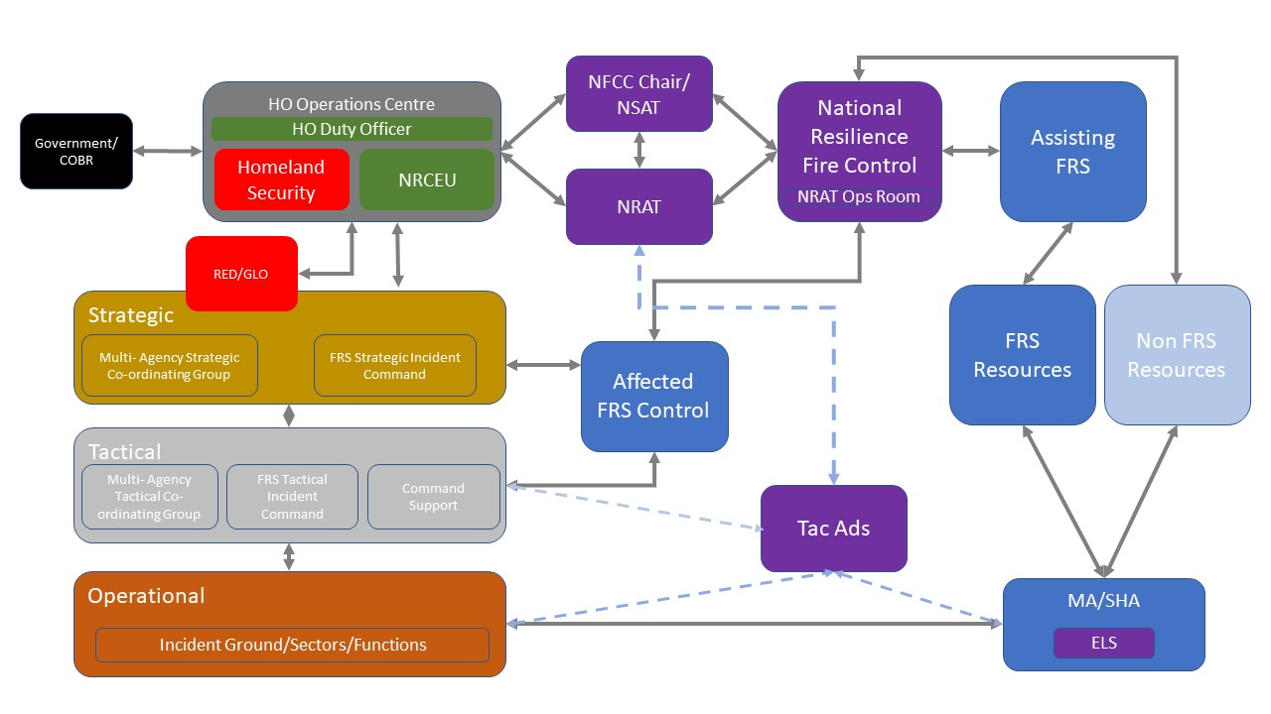

The above diagram represents the NCAF as it operates at a strategic level, and how it is flexible in application depending on the nature of the incident and resources required.

Resource Deployment and Cost Recovery

Emergency preparedness and response occurs both prior to and during an emergency incident.

Pre-deployments

The term pre-deployment is used to describe the early movement of resources to assist with the mitigation of the impact of an identified event, or perceived threat based upon credible intelligence. Depending on the assessed scale of the response, an individual FRS may, through the Chair of the NFCC and/or the NSAT, seek the support of HO to assist in meeting associated costs of pre-deployment. All requests for financial support will be considered by HO on a case-by-case basis.

Post-occurrence

Post occurrence is when a Fire & Rescue Service is in the response phase of an incident. Resourcing and mobilisation of the emergency response will remain with the FRS, and supporting agencies, at the local level. Additional resource requirements will be determined by local commanders. Dependant on the scale of the response, FRSs can seek reimbursement of costs relating to response and recovery through existing finance schemes or those that are announced during and/or post incident by the Whitehall department responsible.

Cost Recovery

The NFCC Guidelines on FRS Charging for Mutual Assistance is a mechanism which provides guidance to donor and receiving FRSs when mutual aid arrangements are activated. This guidance defines types of mutual aid and offers a standardised scale of charges that provide consistency and assurance to all FRSs. The document is updated annually following any pay award negotiation agreed through the National Joint Council. Updates to this document are circulated through a National Resilience Information Note.

International Reciprocal Mutual Assistance

Incoming: International Reciprocal Mutual Assistance

National Resilience Planning within the UK is based on a general presumption of self-sufficiency. The National Security Risk Assessment sets out the government’s assessment of the likelihood and potential impact of a range of different risks that may directly affect the UK, which equates to a relatively small number of occasions where the UK would seek international assistance. In exceptional circumstances where an emergency is of sufficient scale to overwhelm UK capacity, or where highly specialised assistance is required, a request may be considered.

International assistance is requested on a case by case basis following Her Majesty’s Government cross departmental consultation and can only be initiated following a formal request. Co-ordination of such requests should be facilitated through formalised structures such as the European Union Civil Protection Mechanism or following a direct request.

Incoming assistance must be well co-ordinated to ensure rapid and effective integration into the national response. Precise co-ordination arrangements will depend on the given situation. However, plans should be prepared and communicated across a range of Government departments, Local Resilience Forums and agencies well in advance of arrival to ensure that arrangements are understood and work effectively. This will involve the NCAF arrangements and should be made in conjunction with Chair of the NFCC and/or the NSAT, the National Resilience Strategic Lead and the lead Government Department.

Annex B provides an overview of the procedure for the approval of incoming international reciprocal mutual assistance.

Outgoing: International Reciprocal Mutual Assistance

On occasions UK FRS capabilities are required to respond to humanitarian disasters and emergencies overseas. Overseas deployments will be coordinated through the NCAF arrangements and assisted by the Chair of the NFCC and/or NSAT and Lead Government Departments. Any deployment must also be agreed by the NFCC Capability Lead and not impact on the UK’s ability to respond to a national incident.

Following major international disasters, the Foreign and Commonwealth Development Office (FCDO) are able to request fire & rescue resources through a Memorandum of Understanding. This MOU sets out the principles for effective liaison, collaboration, communication and mutual co-operation.

Fifteen fire & rescue services currently form the International Search and Rescue Team under the governance of the NFCC. The team is available to deploy to sudden onset disasters overseas, on behalf of FCDO or the Cabinet Office.

Annex A: Central Government’s response to major incidents

SENT TO HOME OFFICE FOR REVIEW

Annex B International Reciprocal Mutual Assistance

Incoming: International Mutual Assistance

The following procedure is to be adopted for the approval of incoming international reciprocal mutual assistance to the UK:
- FRSs should have exhausted all mutual assistance arrangements/options under sections 13 & 16 of the Fire & Rescue Services Act and assistance that can be sourced via the NRAT Duty Officer from the UKFRS beyond 13 & 16 arrangements.
- A request should be made by the Chair of the NFCC and/or NSAT to Government for the exploration of other national capability options.
- Where COBR is stood up requests should be made via this route. HO NRCEU and CCS will prepare the brief for COBR.

- Where COBR is not stood up, requests should be made to HO NRCEU who will co-ordinate the arrangements with the Civil Contingencies Secretariat (CCS). HO NRCEU and CCS will agree and arrange the necessary Ministerial clearance procedure.

- Once all national options have been exhausted Ministers will approve incoming international mutual assistance requests..

Annex C: NFCC National Crisis Plan Management

COVID Committee to complete

Bibliography

Civil Contingencies Act 2004
Concept of Operations Response to Emergencies April 2013 Cabinet Office
Fire and Rescue National Framework 2018
Fire and Rescue Services Act 2004
Fire and Rescue Services (Emergencies) (England) Order 2007
Multi Agency Strategic Holding Areas – Civil Contingencies Secretariat
National Fire Chiefs Council Mutual aid charging protocol
National Mutual Aid Protocol – Fire and Rescue Service (2006) Fire Service Circular 42/2006
National Operational Guidance – Major Incidents 2018

Glossary

List of acronyms in alphabetical order

A Flood Response National Asset register is maintained through the ESS and includes specialist assets and tactical advisors on call

