HIGH RISE BUILDINGS OVER 18 METRES

HAZARDS

- Fire spread - external
- Fire spread - internal wind driven
- Smoke spread
- Unstable structure
- Cable entanglement
- Wall panel failure
- Falling materials
- Extended lines of communication
- Building security
- Complexity of internal layout
- Failure of fixed installations, engineered solutions and firefighting facilities
- Construction or refurbishment
- Congestion of access and egress routes
- Physical workload
- Persons shut in lifts
- Casualty management

ACTIONS

- Cordon - consider debris, glass, panel failure
- External scan - 360 - TIC
- IBE - additional appliances - evacuation - METHANE message
- Secure lifts (exit 2 floors below fire)
- Communications - mobile phone
- Equipment, tool dump
- Rapid fire condition - safety team prior to attack
- RVP for aerial appliances
- Water supplies - twin - check landing valves
- Max 2 attack and 2 safety jets per riser
- UHPL internally
- Deploy hose reels (6 floors)
- Control access and egress
- Equipment staging area
- Above bridgehead affected by smoke - BA under air
- Above bridgehead not affected by smoke - BA not under air - donned if required by wearers
- Below the bridgehead - no RPE
- Stairwell protection teams with gas detection
- Smoke curtains
- Attack teams - fire sector
- Safety teams - fire sector - protection of attack teams
- Nearest riser outlet - can be fire floor
- Consider external sectors

CONSIDERATIONS

- IBE - GERDA, PEEPs, CCTV, fire action plans
- Preserve scene for subsequent investigation
- Assess all areas affected by smoke for safe air using gas detector
- Drain and secure riser
- Inform responsible person to reinstate the lift

IMAGES
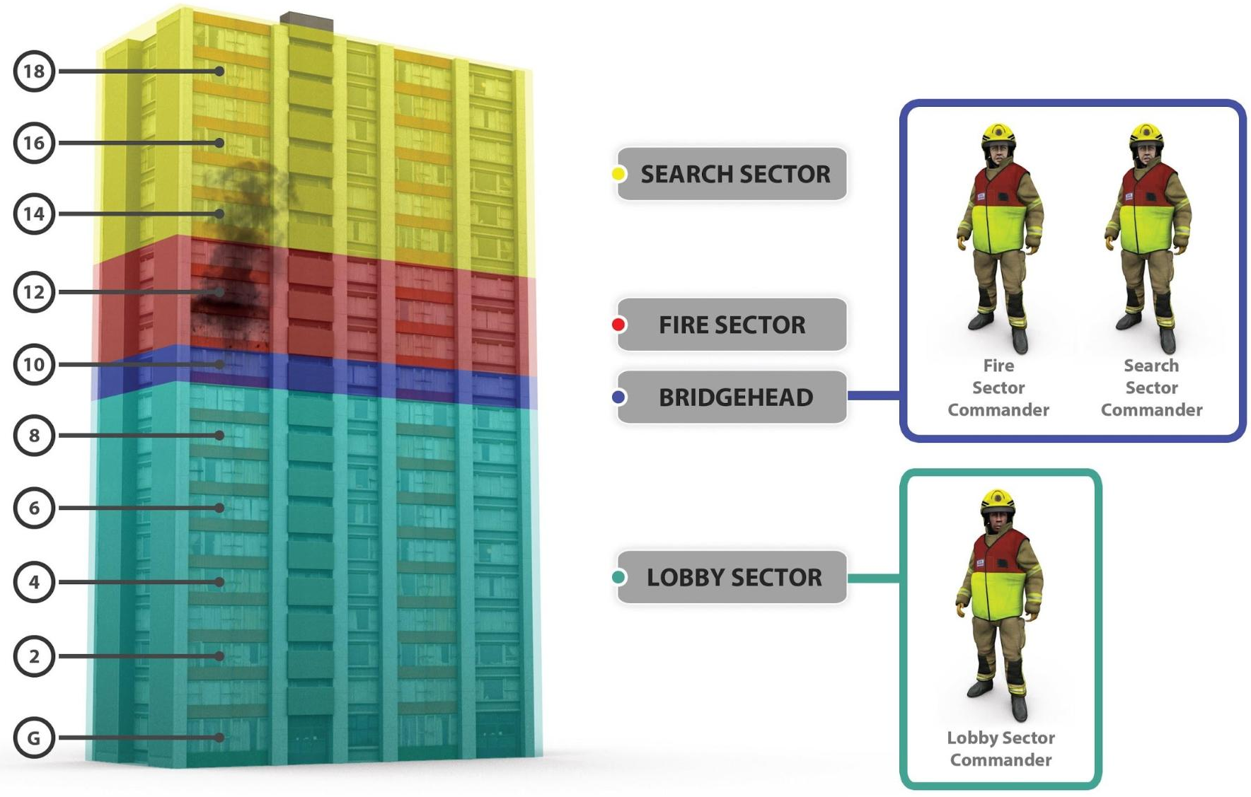
High Rise Sectors

