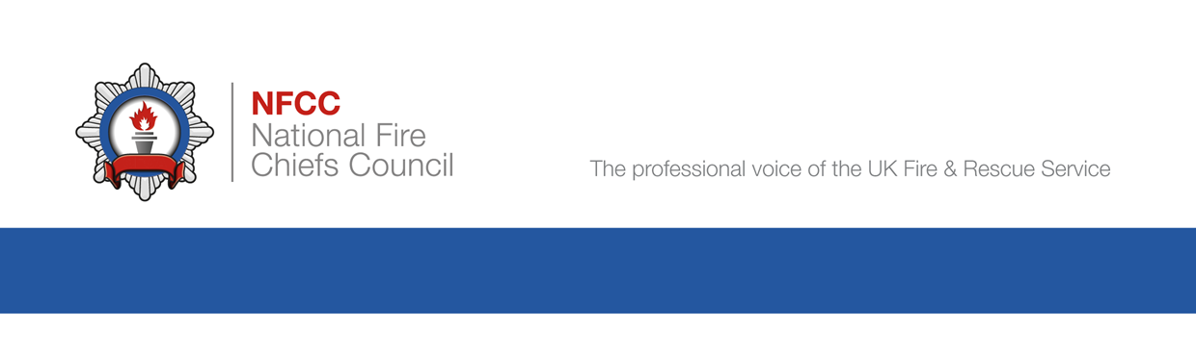

Draft - 040523

Guidance Technical Note
Reducing the impact of fire across the built environment
Guidance on risk, highest risk occupancies and prioritising fire safety interventions

Contents

- A STRATEGIC FRAMEWORK 4
- Purpose of this guidance
- Legislative drivers and government expectations
- Community Risk Management Planning – a strategic approach to reducing risk

- RISK BASED INTERVENTIONS – AN INTEGRATED APPROACH 8
- Key Principles
- Six Risk Groups
- Critical importance of complete premises database
- Principles of ‘Potential Risk’, ‘Actual Risk’ and ‘Residual High Risk’

- CATEGORIES OF ‘RISK’ 12
- Potential consequence factors – ‘catastrophic’ or severe consequences
- Likelihood factors – occurrences of fires
- Likelihood factors – non-compliance with fire safety standards
- Hierarchy of the three categories and priorities for Protection activities

Occupancies with highest potential for catastrophic/severe consequences
- Dependent occupiers and complex evacuation – societal life risk
- Public assembly and complex evacuation – societal life risk
- Major community, societal or economic loss
- Major impact on environment or surrounding communities
- Highest risk occupancies – operational response and firefighter safety

- RISK REDUCTION INTERVENTIONS 20
- Value of proactive interventions – business engagement, Primary Authority, collaboration with other regulators/organisations
- Value of Triaging interventions
- Remote/Desktop Appraisals
- Fire Safety Checks by non-specialist/ops crews
- Inspections by Fire Safety Inspectors – Short Audits, 2009 Audits, principle of ‘Full Inspections’

- STRATEGIES FOR INSPECTION AND INTERVENTION PROGRAMMES 29
- Principle of separate strategies
- Blended approaches to inspections and re-inspections
- Frequency of regular re-inspections

- METHODOLOGIES FOR STRATIFYING RISK AND PRIORITISING INTERVENTIONS 34
- FSEC/IRMP Guidance Note 4
- ‘Definition of Risk’ National Risk Methodology

Appendix 1 – Property databases – principles and guidance 36
Appendix 2 – Six Risk Groups 38
Appendix 3 – Glossary of legislation and guides 41

- A strategic framework for reducing the impact of fire across the built environment.

Purpose of this guidance
- This guidance provides a framework and range of guidance on risk and risk-based interventions to meet the recommendations of the national Community Risk Planning Guidance and Fire Standards. The framework will support Services to demonstrate consistency in defining and prioritising risk, and decisions on interventions to reduce the impact of fire that take account of the workload demands they face. Through integrating the interventions across Prevention, Protection and Response functions it supports reduction in fire risk across the built environment and to communities.
- This guidance, particularly Sections Two to Six, also specifically supplements and updates the existing Government guidance enshrined in IRMP Guidance Note 4 2009. These provided a methodology for the FRS to monitor compliance with the Regulatory Reform (Fire Safety) Order 2005 through a ‘risk-based inspection programme’ to meet our duties under the National Framework 2018.
- These were drafted some years ago and it is appropriate to provide updated guidance to take account of a greater understanding of risks, foreseeable events and challenges. Some of these factors are:
- Greater understanding of substandard design and construction within the built environment.
- Greater understanding of potential future changes to risk created by an ageing population, modern methods of construction, engineered solutions and technological changes.
- Evidence of continuing poor standards of Fire Risk Assessment and compliance with the Fire Safety Order in certain premises – potentially leaving people and property at risk particularly in the highest risk occupancies described in Section Three of this guide.
- Greater understanding of the complexity, challenges and risks of evacuation particularly for occupancies with ‘Stay Put’ or other delayed evacuation strategies designed to support vulnerable and dependent occupiers.
- Challenges in recruitment, retention and competence of FRS Staff.
- It is recognised that any major changes to existing approaches will take significant resources and time to achieve and that more than one approach is likely to be valid. However, some adjustment and alignment of core principles will bring greater commonality and consistency of approach.

Moving from ‘inspections’ to ‘interventions’
- The IRMP Guidance and Government National Framework 2018 guidance also tends to focus only on ‘inspections’ as the core function of Risk Based Inspection Programmes. However, this new guidance recognises the value of broadening this to include a wider range of ‘interventions’ that all contribute to reductions in risk. Examples of these include: desktop or remote appraisals, Fire Safety Checks, Short Audits, Audits, Business Engagement activity, Home Fire Safety Visits, ‘post fire’ local prevention visits, online tools and general marketing campaigns.
- As such this guidance, particularly Sections Three to Six, are primarily aimed at the Protection departments within the FRS but may also add value to Prevention and Response functions by suggesting methods of integrating interventions. It also recognises that many occupancies, particularly within the highest risk multi occupied housing sectors, may require interventions from both Protection and Prevention resources to reduce risk.
- Most importantly it also emphasises in Section Two the need to express within both CRMP Frameworks and Protection Strategies clearly how the interventions contribute to reducing the differing types of risk.

Legislative drivers and Government expectations
- The core Statutory role for the FRS in relation to Fire Safety duties are imposed by the Regulatory Reform (Fire Safety) Order 2005 (RRO), and the Fire and Rescue Services Act 2004. These are underpinned by the current national government guidance (National Framework 2018 and IRMP Guidance Note 4: 2009) that provide broad direction on the approach that Fire and Rescue Services should take to their Protection and Prevention activities.
- Government expectations of the FRS in monitoring compliance with the legislation are enshrined within the guidance mentioned above and related guidance. These do not provide any detail on the specific nature of interventions other than inspections. They provide a methodology for setting generic levels of relative risk between some occupancies, but they make no detailed recommendations for any targeting of specific buildings/occupancies or the frequency of monitoring/re-inspections.
- They are broad based and simply establish the principle of focusing resources and priorities on ‘risk’, leaving it to FRS to determine the types and levels of risk, and how they will allocate resources to mitigate these risks and monitor compliance.

National Framework 2018
- The National Framework is similarly broad based and establishes some outline principles for both Prevention and Protect activities as listed below:
Prevent and Protect ​
2.3 Fire and rescue authorities must make provision for:​
- promoting fire safety/fire prevention, ​
- …have a risk-based inspection programme in place for enforcing compliance with ….. the RRO. ​
2.4 We expect fire and rescue authorities to target their… prevention and protection resources on: ​
- those individuals or households who are at greatest risk from fire in the home; ​
- those most likely to engage in arson or deliberate fire setting; ​
- those non-domestic premises where the life safety risk is greatest. ​
- Consideration could also be given to non-domestic premises which are at risk from fire in order to mitigate loss to economic wellbeing. ​

Fire Standards
- The Fire Standards Board is responsible for developing and maintaining a suite of Fire Standards for fire and rescue services in England for the benefit of Services and the communities served by them. These will cover all of the core activities across the Protection, Prevention and Response functions.

Government Consultation Paper – Reforming our Fire and Rescue Service (18 May 2022)
- A consultation Reforming our Fire & Rescue Service was published in May 2022 and any decisions on changes to the functions of the FRS that may flow from this white paper have not yet been established, and the impact on resources and targeting of risk-based interventions is not yet known.

Fit for the Future 2022
- This is a series of improvement objectives drafted jointly by the National Employers, Local Government Association, and NFCC. Its purpose is to “Set out an evidence-based picture of the future role of fire and rescue services, informing work relating to employee roles and the HMICFRS recommendation about clarifying the future role of the fire and rescue service”. ​Decisions on changes to the functions of the FRS that may flow from this white paper have not yet been established, and the impact on resources and targeting of risk-based interventions is not yet known.

Community Risk Management Planning – strategic approach to reducing risk
- The NFCC Community Risk Management Planning Guidance provides comprehensive guidance for the FRS on developing their CRMP and this includes a ‘Conceptual Risk Framework’ model to underpin this which is shown in Diagram 1 below.
- The main components of the CRMP guidance within this model are:
- Scope Definition
- Hazard identification and Groups at Risk
- Risk Analysis
- Decision Making
- The stages of this process are supported by further guidance on:
- Data & Business Intelligence
- Equality Impact Assessment
- Stakeholder and Public Engagement
- It is envisaged that fire and rescue services will adopt this Framework and guidance as the basis for their own CRMP process. In doing so, it will also help with aligning to the content and requirements detailed in the Fire Standards, as the framework has been used as the foundation for the Fire Standards development. This Conceptual Framework underpins the approaches and methods for prioritising risk-based interventions by Protection departments discussed in Section Two of this guidance.
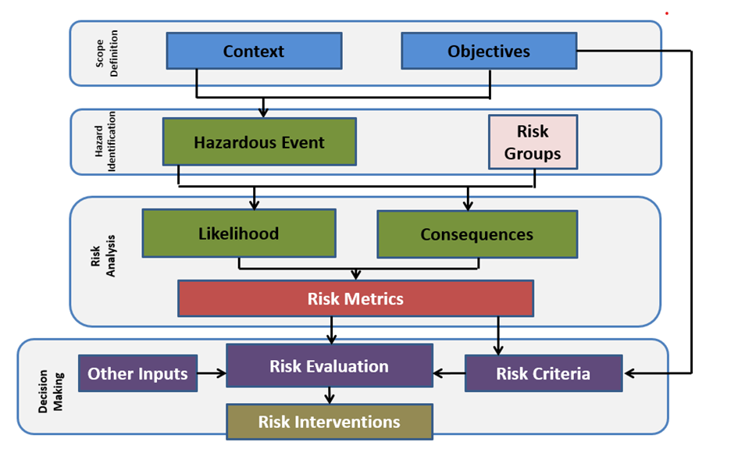
Diagram 1 – CRMP Conceptual Risk Framework

- Risk Based Interventions – An Integrated Approach
Key Principles
- The framework in this section describes an integrated prevention, protection, response and partnership approach to reducing the risk of fire in the built environment.
- It recognises the value of previous IRMP guidance and variations in the organisational structure, resources, competencies and existing approaches across the FRS. It also recognises that each FRS will be at a different stage of the journey towards identifying and understanding risks across their built environment and recording/ disseminating risk information.
- The CRMP should recognise the value and contribution of any FRS interaction with a building and will therefore not be confined to Protection functions only. The contribution of Operational Crews, Community Safety staff through HSVs, Ops Fire Safety checks, SSRIs/ PRAs, alleged fire risks and incidents - in addition to business engagement and education, remote/desktop appraisals, short audits and full audits will all assist in the understanding and reduction of premises risk.
- A key principle is that any intervention between an FRS member of staff or a partner with a premises in whatever capacity is an opportunity to reduce the overall risk and/or impact of fire in that premises.

Six ‘Risk Groups’
- The CRMP Conceptual Risk framework on page 7 above identifies an element called ‘Risk Groups’, and this has been further divided into six ‘Risk Groups’ (diagram 2 below) for the purpose of this integrated approach and model.
- Throughout historic IRMP and Operational Risk guidance a number of categories of risk are referenced in varying terms (eg societal risk, heritage, community, economic risk etc.) For the purposes of this model, they have been rationalised to create the following six categories to capture the focus for all interventions. These are:
  - Individual Life Risk – The potential for the death or injury of an individual or small group within a single fire compartment. For example - occupants of a flat or house.
  - Societal Life Risk – The potential for death or injury of multiple individuals or groups in multiple compartments due to the fire not being contained and spreading before individuals can evacuate. This is the primary focus for Protection activities, but it is recognised that it is interdependent with the other risk groups.
  - Firefighter Risk – The potential for the death or injury of a firefighter due to the hazardous items or processes contained within a premises, complex layout or where firefighters are unable to use their normal safe systems of work and require an adapted tactical firefighting plan for the premises.
  - Heritage Risk – The potential for the partial or total loss of items, premises or sites of heritage value through their heritage listing or otherwise historic value.
  - Community Risk – The potential for a fire to create severe consequences on a local community or economy. This may be linked to public risk, sense of wellbeing, mental health, financial security, loss of critical public services, political and media impact etc. eg loss of a school, hospital, major transport hub or major local employer.
  - Environment Risk – The potential for a fire or other incident to negatively impact the environment in the immediate or wider vicinity of a premises through the production of environmental hazards or firefighting interventions required to extinguish the fire.

Note: Each of the six risk ‘groups’ is described in more detail in Appendix 1.
Diagram 2 – Six Risk Groups and example interventions
- A key principle behind this framework and the six risk groupings is to clearly demonstrate a holistic view of risk across the community and how FRS interventions are targeted at reducing risk across one or more of these areas.
- Each of these requires a different primary intervention, or a range of interventions to support the reduction of risk of fire and examples of these are indicated in Diagram 3 above.
Note: The Economic/Social Value Impact of fire is regularly highlighted as a risk but for the purposes of this guidance it is not deemed to be a separate risk category. Rather it is intrinsically linked to risk reduction in all the six other categories. A reduction in fire risk in each category will by its nature reduce the economic/social value impact risk.
- Importantly it also recognizes that although the risks are divided into six categories these are not independent of each other and reduced risk in one category will often reduce risk in other categories particularly where there are multiple interventions.
Note: Example of the integration between Protection, Prevention and Response interventions:
An individual person is referred to the FRS due to Level 8 hoarding in a sheltered housing flat. A home fire safety visit (or safe and well visit) and local authority Housing and Safeguarding engagement is focused on reducing the risk to the individual. A protection officer may have also audited the premises to check that the compartmentation and other fire safety measures are in place to reduce potential for fire spread and therefore reduce the Societal Life Risk to occupiers of other flats. Firefighters also carry out a SSRI (7(2)(d)) visit and develop tactics and knowledge that will reduce the risk to themselves and other residents in the event of a fire in that flat or others.

Critical importance of a complete premises database
- Any risk-based approach relies on the capacity and functionality of the building risk database to record the interventions and levels of risk, and to inform future re-inspection or other intervention frequencies based on the actual risk within a premises.
- In order to integrate risk reduction across Prevention, Protection, Response and Partners it is recommended that FRS have a complete and premises-based building risk database and that a level of risk is recorded for each of the six risk groups outlined above. There have been many instances where information relating to risk held by one department within a FRS has not been accessible to other staff groups or departments due to being held on different databases. This has been detrimental to operational managers at incidents and also to staff inspecting premises.
- A building risk database will be most valuable if it contains all buildings and risk information that is as up to date and relevant as possible and the risk information is available to those who need it when they need it. Further information on property databases is given in Section Three of this guidance.

Principles of Potential Risk vs Actual risk
- Current approaches to risk-based programmes incorporate both ‘potential’ and ‘actual’ risk. An initial generic risk level is applied as a measure of ‘potential’ risk and application of the knowledge gained at interventions within individual buildings/occupancies will refine this initial generic risk level to create a measure of ‘actual’ risk.
- There are many data sources that can help identify the initial ‘potential risk’ of fire in a generic occupancy type – whether this relates to the likelihood or the consequence factors. These can range from past incident data, FSEC model metrics (relative risk scores, fire frequencies etc), MOSAIC, Experion, partner data, other regulators, national statistics etc. This data may be valuable to inform the level of potential risk of a generic occupancy type but is less helpful in informing us of the ‘actual risk’ of an individual premises until it has been visited.
- The ‘actual risk’ is dependent on occupant dependency, use, fire safety management, building attributes such as height, size, layout and construction quality and can only be ascertained through direct or indirect interactions with premises and their occupants.
- Knowing the actual risk of all individual buildings/occupancies also enables an FRS to allocate specific competency levels to inspections or fire safety checks. If this is achievable for all premises in a FRS area it will enable the FRS to anticipate and plan for workforce numbers, competence development and prioritisation of workload and the associated budgeting. However, it is recognised that this is a considerable commitment, particularly for Services with large metropolitan areas, and will take many years to achieve. If it is not practicable or achievable for some services given their resources or demographics it is recommended that the priority should be on assuring the accuracy of data held on their known highest risk occupancies.

Principle of ‘Residual High Risk’
- The concept of ‘residual high risk’ has been introduced to recognise that in certain occupancies – particularly those with delayed or complex evacuation strategies and dependent occupiers as discussed in Section Three of this guidance – a higher level of risk to life and communities will always remain.
- This will be the case even if the building protection and management arrangements appear to comply with the current standards and Fire Safety Order. This is due to a critical reliance on both active and passive fire protection systems, management arrangements, numbers of staff, and their decisions and performance to implement effective and safe evacuation. These last ‘human factors’ have often been a common theme in fires which have resulted in casualties or required rescues.
- Although this permanent level of ‘high residual risk’ means that they should remain a priority for appropriate levels of monitoring and interventions, decisions about prioritisation and frequency will still be based on some local evaluation of building and occupancy attributes. It is recognised that interventions don’t necessarily always have to be physical audits as proactive business engagement and education initiatives may be equally or more valuable. Similarly, when physical audits are appropriate It may also be sufficient to carry out remote appraisal or fire safety checks to confirm the same management is in place and that fire safety management standards and staff training/awareness have remained as seen during the previous intervention.
- The types of occupancies identified as ‘high residual risk’ and the risk influencing factors are described in more detail in the next section of this guidance.
- Categories of fire risk and their hierarchy in identifying highest risk occupancies and prioritising interventions
- Risk analysis is generically defined as a consideration of the factors that contribute to both the likelihood and consequences of a hazardous event (such as a fire), and the application of a metric to prioritise the ‘levels’ of risk between occupancies. The core purpose of this prioritisation is to enable FRS to focus their resources on the ‘highest risk’ occupancies.
- However, ‘risk’ can also be expressed in a number of different ways from the FRS Protection perspective, and these may be partly responsible for some of the current variations in RBIP approaches.
- For the purposes of this guidance, it is useful to interpret and clarify some main categories of fire risk that can be applied to the built environment from a Protection perspective. This also enables a consideration of the hierarchy of these types of risk and their relevance to prioritising interventions at various occupancies. Three higher risk ‘categories’ are shown in diagram 3 below, and are further discussed below.

Diagram 3 – categories of fire risk and heirarchy

Potential consequence factors – ‘catastrophic’ or ‘severe’ consequences
- This category can be described as the potential for either catastrophic or severe consequences should a fire develop. Catastrophic can be defined as multiple fatalities or injuries, major loss of critical community assets, or economic/heritage/environmental impact from uncontrolled fire or smoke development.
- The category of potential life risk already underpins and is key to the original government IRMP GN 4 guidance which states ‘the inspection programmes allow each FRS to demonstrate it is delivering its enforcement responsibilities and focusing its resources on those premises that represent the greatest risk to life in the event of fire.’ This principle of ‘societal life risk’ was defined in that guidance as the potential for five or more fatalities in any one incident.
- Historic data analysis, metrics and algorithms are included in that relative risk methodology to provide a hierarchy of generic occupancy types and levels of potential risk. However, it is recognised that this data within IRMP GN 4 is outdated and that calculating new metrics for the potential for life risk consequences using empirical data is complex due to the relative infrequency of such incidents, variable IRS data and influencing factors involved.
- A national analysis of fire consequences (table 1 below) by 23 occupancy types has been determined in 2023 by analysis of six years (2014-2020) of IRS data within the Definition of Risk national methodology project. This measured the consequences of fires using a variety of fields including fire extent damage, fire spread, evacuations, fatalities, injuries, and FRS resources applied. This analysis indicated that the highest proportion of fires classified as ‘High’ consequence involved HMOs, Sheltered Accommodation, Other Sleeping Accommodation, Care Homes and Prisons.
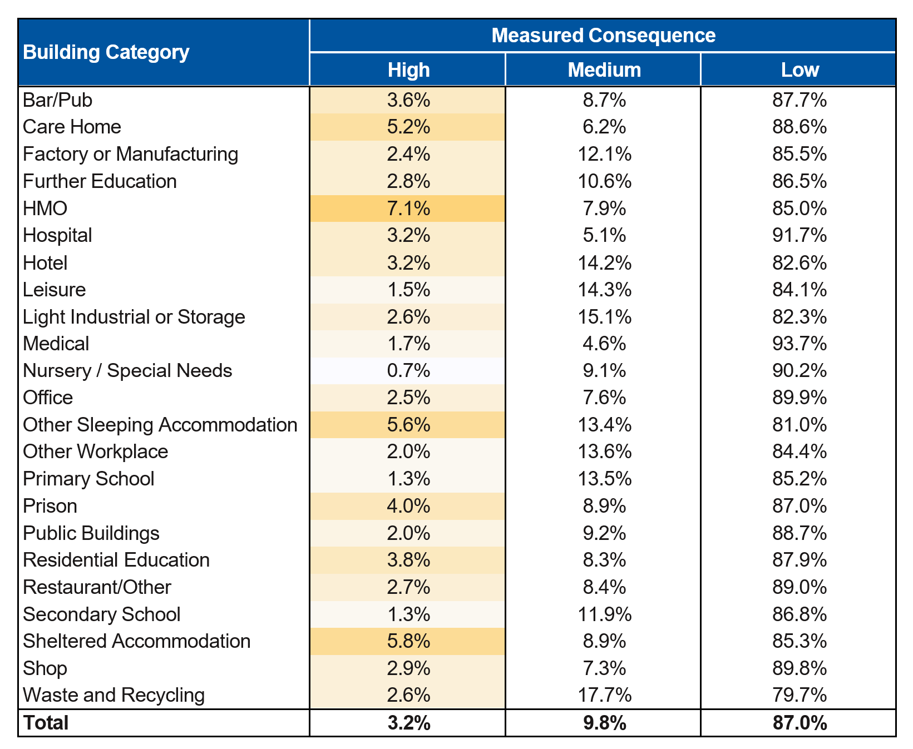
- It is recognised that, although classified as ‘High’ in this particular analysis, very few of these recorded fire incidents had the ‘catastrophic’ outcomes described above as these are relatively rare occurrences statistically.
Table 1 – building categories and fire consequences 2014-2020 (IRS Data)

Likelihood factors – occurrence of fires
- Likelihood of a fire occurring is also reflected in the existing national IRMP Guidance Note 4 methodology, which identifies the ‘relative risks’ between occupancy types. This is also now limited in accuracy due to the age of the data, our improved understanding of design, build quality weaknesses within the built environment, and changes in the use of buildings that have increased complexity.
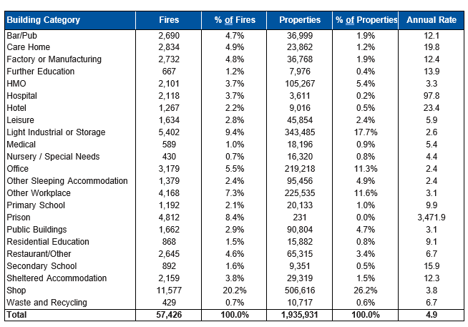
- However, the national annual rate of fires by 23 occupancy type has also been determined in 2022 by analysis of six years (2014-2020) of IRS data by the Definition of Risk methodology project and the relative levels are shown in Table 2 below. These indicate that the highest annual rate of fires are in prisons, hospitals, hotels, secondary schools, and care homes.
Table 2 – Annual rate of fires 2014-2020 (IRS Data)

Likelihood factors – non-compliance with fire safety regulations and standards
- Most FRSs also focus resources on this category as it is a statutory enforcement duty for FRSs. National statistics indicate a high proportion of enforcement action is taken against shops and licensed premises (possibly due to failures in separation between the commercial element and living/sleeping accommodation above them rather than just risks within the retail parts themselves), and also houses converted to flats, and some other types of sleeping accommodation such as HMOs, hotels and guest houses.
- Although some of these occupancies are less clearly in the primary categories of highest ‘societal life risk’ it is recognised that they may, in general, experience lower standards of fire safety management, and higher rates of enforcement. Many of these are therefore likely to remain a priority for interventions within most authorities, although many may be unknown to the FRS and are the joint responsibility of other regulators such as Local Housing Authorities.

Hierarchy of these three risk categories and priorities for Protection activities
- To provide direction and priorities for Protection and Prevention activity, the Home Office published the Fire and Rescue National Framework for England, which outlines a number of expectations on how these three relative categories of ‘highest risk’ may be prioritised:
‘2.4: We expect fire and rescue authorities to target their fire safety, prevention and protection resources on: those individuals or households who are at greatest risk from fire in the home; those most likely to engage in arson or deliberate fire setting; and on those non-domestic premises where the life safety risk is greatest. Consideration could also be given to non-domestic premises which are at risk from fire in order to mitigate loss to economic wellbeing.’
- It is evident from this direction that that the life safety risk remains the key priority for protection activity from the Government perspective. Fortunately, uncontrolled fires with multiple fatalities or catastrophic consequences are very infrequent in the UK with Summerland, Woolworths, Denmark Place, Wensley Lodge, Kings Cross, Dream City, Bradford Football Stadium, Fairfield and Rosepark Care Homes, and Grenfell Tower being most notable in recent decades. However, these severe fires continue to occur, with fires such as Newgrange Care Home, Beechmere Extra Care Sheltered Flats, the Cube, Croft Care Home, Worcester Park, and Barking residential flats all being very significant. These and many other fires in schools, hospitals and multi occupied residential buildings have been challenging for FRSs, and in many cases could have resulted in more fatalities and injuries had the circumstances been slightly different.
- These incidents have also all demonstrated that the societal impact consequences of a fire in certain occupancies can potentially be catastrophic and last many years, either in terms of life risk, loss of critical community assets, and/or economic/environmental impact. We also know from many fire investigations and fatal fire inquiries that those most vulnerable to fire are those who are least likely to be able to escape from the building, should a fire occur. Furthermore, we now have a greater understanding that poor standards of building design and construction, non-compliance with Building Regulations, poor fire risk assessments and poor management is more common than previously assumed. All of these factors provide potential increased likelihood of factors that will compromise evacuation, firefighting, and rescue operations.
- On balance, although all three of the parameters for ‘highest risk’ outlined above will continue to be relevant, it is evident that the relative priority for Protection activities remains on those occupancies with the highest potential for catastrophic or severe consequences and these are explored further below.

Occupancies with the highest potential for catastrophic or severe consequences, and key risk influencing factors
- There have been many consultation responses and working group submissions made to Government by NFCC, individual FRSs and other organisations over the last three years as part of the Building Safety Act, the Fire Safety Act, the Fire Safety (England) Regs and Grenfell Tower Inquiry considerations. These submissions expressed the professional judgement of NFCC and individual FRSs, and examples of the highest risk occupancies identified in those various submissions are summarised in Table 3 below:
Occupancy Types | Key Factors which influence Potential Risk
- Hospitals and hospices  - Care and nursing homes  - Specialised housing. For example:  - Sheltered housing (multi occupied)  - Supported living (multi occupied)  - High rise residential blocks or other occupancies (in particular those with interim measures in place due to non-compliant external wall systems or compartmentation issues  - Schools  - Major entertainment and public assembly buildings  - Secure facilities: (although regulatory responsibility sits with other agencies) | - Reliance on complex or specialised risk management.  - Reliance on complex or delayed evacuation strategies with critical staffing levels, training and competence.  - Vulnerability of occupants and dependency on others for evacuation.  - Sleeping and non-sleeping risks.  - Building size and complexity, and the number of staircases and means of escape.  - Quality of compartmentation and passive protection  - Complex design and/or construction, such as engineered, timber frame, and modern methods of construction.  - The composition of external wall systems.  - Exceptional value to the community or society.  - Complexity or delays in firefighting.

Table 3 – Highest risk occupancies and risk influencing factors

- The reasons for these specific buildings/occupancies being identified as highest risk within these submissions also appears to be underpinned primarily by the potential for catastrophic or severe consequences should fire or smoke develop and spread. These impacts were attributed to the influencing factors mentioned above, such as complexity and delays in evacuation, dependency of the occupants, failures in building design or construction, and potential for delays in firefighting.
- These key risk influencing factors are described further within the four categories below.

Dependent occupiers and complex evacuation – societal life risk
- These are occupancies with complex or delayed evacuations strategies – evacuation strategies that result in some or all occupiers remaining in the building (or parts of the building) during a fire incident at least for the initial stages, and potentially for an extended period.
- These occupancies also often have vulnerable and dependent residents. This could include a reduced ability to respond to an alarm sounding or fire, reduced levels of mobility and slower movement, dependency on support to evacuate, increased vulnerability to the effects of fire and/or smoke, or to injury from emergency evacuation or rescue handling.
- In these cases, the safety of occupiers will also be critically dependent on protection measures within the building, effective risk management, emergency/evacuation plans, sufficient staffing numbers, and the decision making, response and actions of staff in a fire situation.

Dependent occupiers and complex evacuation – societal life risk
- Hospitals and hospices  - Care and nursing homes  - Sheltered and Extra Care Sheltered housing (Multi occupied)  - Supported living (Multi occupied)  - Hostels for vulnerable or dependent residents | - Residential boarding schools and schools for vulnerable/dependent pupils  - Secure Facilities, (although regulatory responsibility sits with other agencies)  - Prisons  - Young offender institutions  - Detention centres

Public assembly and complex evacuation – societal life risk
- This category involves public assembly occupancies which have complex evacuation strategies and/or a high number or density of occupants. In these cases, the potential for panic and injuries through falls and crushing is heightened, meaning there may be delays in movement, and encouragement and direction by staff may be critical for safe evacuation.

Public Assembly and complex evacuation – societal life risk
- Major entertainment and public assembly buildings – eg nightclubs, theatres, music venues, stadia
- Residential blocks or other occupancies with interim measures in place due to non-compliant external wall systems or compartmentation issues

Major community – societal or economic loss
- This category takes into account occupancy types where a fire may result in the partial or total loss of a critical community asset, or major disruption and financial loss to communities, society or the economy. Some of these are also included in the societal life risk category above.

Major community, societal or economic loss
- Hospitals  - Care and nursing homes  - Residential blocks  - Sheltered Housing and Supported living  - Schools (all types)  - Major historic or listed buildings with valuable heritage assets | - Major public and government buildings  - Major national infrastructure  - Major transport hubs  - Major retail centres  - Major industrial complexes

Major impact on the environment or surrounding communities
- This category is primarily concerned with occupancy types which could have a substantial negative impact on the environment or local community in the event of a fire. This may be due to close proximity to sensitive environmental receptors, such as rivers, lakes, other bodies of water, or critical community assets, such as hospitals, housing estates, and transport infrastructure.
Environmental impact
- COMAH sites
- Major hazardous materials storage sites

Highest risk occupancies – operational response and firefighter safety
- FRSs have the difficult challenge of ensuring an effective operational response and tactical approach should a fire occur in a higher risk occupancy.
- FRSs cannot be expected to fully mitigate fire development in buildings that have not been constructed to the standards enshrined in the Building Regulations and may not be able to provide a safety net where these types of buildings are unknown to the FRS. However, it is recognised that many FRSs have recently increased their operational response standards and adjusted their tactical approaches to high rise residential buildings in response to the Grenfell Tower Fire. In particular, this has been to account for known structural defects, flammable external wall systems, and changes to evacuation strategies.
- FRSs now have greater experience and understanding of weaknesses in the design and construction of the built environment, and the increased potential for uncontrolled fire and smoke spread to compromise complex evacuation strategies. The impact of these factors on firefighting tactics is also recognised and it is therefore appropriate to consider the other higher risk occupancy types, irrespective of height, identified in this paper for similar adjustments to tactical approaches.

- Risk reduction interventions

Value of proactive interventions – business engagement and education, Primary Authority, collaboration with other regulators and organisations
- The legislative duties for keeping occupants safe within premises lie with Responsible Persons and any appointed competent persons (ie Fire Risk Assessors). The Secretary of State has the duty to ensure appropriate guidance is available to assist Responsible Persons to discharge these duties.
- The key challenge for the Responsible Persons and their appointed Fire Risk Assessors is to understand these responsibilities and guidance to establish and maintain appropriate fire safety standards. This is particularly important within the highest risk occupancies with complex risk management regimes.
- The FRS have been regulating compliance for many decades, and the primary tools for this work have been the inspection and fire safety check regimes driven by risk-based programmes. However, the national statistics and experiences of FRSs demonstrate continuing levels of non-compliance and the need for enforcement action. A periodic inspection or check, including regulatory action if needed, may not therefore be the most effective way to raise and maintain standards if inspections only focus on specific individual failures within a building or its management arrangements.
- This is particularly concerning for the highest risk occupancies discussed above. It may therefore be appropriate to reconsider the relative value of audits and inspections as the primary tool for reducing risk if they are evidently only having a temporary impact on fire safety understanding and compliance among building managers and Responsible Persons.
- The key challenge for the FRS is therefore to strike the right balance between two primary objectives when prioritising their business engagement, inspection and reinspection activities. These are:
  - The broader ‘prevention objective’ to support building occupiers and operators to understand, establish and maintain fire safety standards. It is particularly important within known highest risk occupancies to support Responsible Persons and local managers to understand that they have responsibility for a complex and highest risk building, and to better understand the implications and control measures required to control and manage that risk. This improved understanding will support those Responsible Persons and local managers to maintain the safety of their occupants and anticipate the needs of FRS responders should a fire occur.
  - The narrower statutory duty to ‘monitor and enforce’ legislation in accordance with the Fire Safety Order and Regulators Code across the wider built environment – primarily achieved by inspections and fire safety checks.
- FRSs may therefore wish to consider whether applying resources to additional proactive interventions could be more effective at encouraging compliance and reducing risk. This is particularly relevant to the highest risk occupancies described above and a risk-based approach would suggest that the majority of these activities should be focused on those highest risk business sectors. Examples of some successful interventions already being delivered by FRSs are provided below:
  - Primary authority schemes and MOUs with larger organisations operating highest life risk occupancies (for example care and housing sectors) with the objective of supporting those organisations to improve their strategic oversight and policy driven standards for fire safety.
  - Collaboration directly with highest risk sector stakeholders and other regulators in order to train their staff in basic principles of fire safety, so that they can identify signs of risk or failure and address these issues or make referrals to the local FRS. Examples of these collaborations are with Local Authority Care and Housing Commissioners and Contract Managers, Care Quality Commission Inspectors, OFSTED, NHS, and Trading Standards and Environmental Health officers. Some of these organisations will already be covered by MOUs, protocols or concordats with NFCC and/or other regulators.
  - Training workshops, seminars and joint exercises directly with groups of managers from private sector organisations operating highest risk occupancies, such as care home operators, care provider companies, housing providers, and trade associations.
  - Arson reduction and security initiatives for schools.
  - Fire safety promotional material targeted at specific sectors.
  - Letters and themed guidance to operators, managers, and residents of specific occupancies.
- The NFCC website and Protection and Prevention groups on Workplace provide forums for sharing best practice examples of proactive interventions. Similarly, the NFCC Virtual Learning Environment may have useful material that can be used to inform stakeholders and partners, and NFCC would encourage FRSs to consider these approaches if they have not already done so.

Value of triaging interventions
- The aim of Risk Based Planning is to reduce the impact from fire across the built environment by effectively utilising staff to carry out engagement activity to identify and reduce the risks of fire, particularly in the highest risk premises.
- It is clear that most FRS will have continuing challenges in their Protection and Prevention functions with recruitment, retention, maintaining competencies, balancing resources, and workload being a foreseeable challenge for some years to come. Most will not be able to visit every unknown premises in their area to evaluate risk, nor inspect all of their highest risk premises every year or even every few years. Therefore risk-based planning needs to contain effective triaging and a flexible range of methods to ensure that resources are focused on the highest risk premises as a priority.
- The Building Risk Review project and adaptation of inspection approaches to cater for pandemic conditions has demonstrated that fire and rescue services can be much more flexible in the way they interact and reduce risk. Proactive business engagement and education, intelligence gathering, ‘Remote’ or ‘Desktop’ appraisals, short audits, full audits and enforcement can all be regarded as different interventions in a staged risk reduction process.
- This also reflects the principles outlined within the CFOA Fire Safety Guidance Notes and Audit on prioritising premises to visit. That states that the fire safety approach starts with intelligence gathering to assess safety and collect risk data about premises in a systematic and consistent manner.
- An effective triage and recording process will provide, over a number of years, an increasingly accurate database to enable the FRS to accurately inform future risk reduction activities and the level of engagement activity and/or intervention required.
- The same principles of ‘triaging’ and prioritisation of the highest residual risk could be applied to other ‘demand led’ workload such as consultations from Local Authorities on Licensing, Planning and Building Control matters. It is recognised that some of these are driven by Statutory requirements on other Regulatory bodies rather than as a Statutory requirement of the FRS. However, in many cases these requirements were established some decades ago, do not take account of current workloads, and conflict with the principles of risk-based approaches which should focus limited resources on the highest risk occupancies.
- It is recommended that triaging processes for demand led workload is focused on minimising resources spent on these if they do not relate to highest risk occupancies. Many FRS have agreed protocols with Local Authorities to ensure that only consultations on premises of concern are sent to them for consideration and information

Remote/desktop appraisals
- The 2021 survey also identified that 25 (67%) of FRSs had recently adopted, primarily as a result of Covid guidance and restrictions, a desktop appraisal process completed by telephone and/or email.
- There has not been any formal evaluation of the value or impact of ‘Desktop Appraisals’ on the reduction of risk to occupiers of buildings or the public. However, it is recognized that this ‘value’ could accrue through four potential outcomes:
  - Identification of minor failures in general fire precautions – and provision of verbal or written advice that remedies the failures without further physical inspection.
  - Identification of major failures in general fire precautions – and the need for physical inspection to determine Audit/Enforcement Action to remedy the failures.
  - Provision of general advice, encouragement and reminders that result in RPs maintaining a focus on fire precautions.
  - Reduction in time spent on physical visits to lower risk premises – and therefore increased capacity to inspect higher risk premises.

- FRS used a variety of approaches and an overview of the three primary approaches is provided and described below.
Triage Only
- Gather information electronically
- Confirm existing arrangements
- Decide further actions:
- Advisory or regulatory appraisal
- Inspection or fire safety check

Advisory Appraisal Process
- Gather information electronically and verbally
- Confirm basic fire safety arrangements
- Decide if further actions or information required
- Give advice
- Record information and outcomes

Regulatory Appraisal Process
- Gather information electronically and verbally
- Confirm all fire safety arrangements
- Calculate risk level or category
- Decide if further actions or information required
- Give advice
- Record information and outcomes

Diagram 3: Approaches to Desktop Appraisals
- Some FRSs use a form of desktop appraisal purely as an initial sifting or triaging tool to determine whether a physical inspection is likely to be required and its priority. Some FRSs also had similar processes delivered by both Protection specialists and Operational staff to triage their actions.
- Some were purely advisory in nature and prompted occupiers to maintain their focus on certain fire safety arrangements, such as staffing levels, fire alarm testing and staff training. These also gave some opportunity to gather some preliminary information to determine whether any further action, such as physical inspections or checks were required.
- Others had more formal regulatory intention and included extensive formal detailed questions about fire safety arrangements, Fire Risk Assessments or other related documentation. These were often structured around the CFOA Short Audit methodology and also provided information to determine whether further actions, such as physical inspections or checks were required.
- Some services have also trialled the use of cameras on mobile phones and/or tablets by local premises managers to enable a remote view of arrangements by inspecting officers to support their appraisal. ​Others trialled the use of video calls to interview premises managers.
- However, feedback from FRSs about the value and efficacy of desktop appraisals has been varied and very little formal evaluation has been carried out to date. It is recognized that although these can be less resource intensive (in Officer time) than a physical audit of a premises, they can still take significant time to arrange and complete. If the value in identifying and reducing risk is limited, they will not provide an effective use of time and resources in any event, irrespective of whether they are completed by inspecting officers, fire safety advisors, operational or administrative staff.
- Anecdotal evidence was provided by some FRSs that indicated a limited commitment to continuing with them now that Covid restrictions have been lifted due to the resource implications and difficulties in gathering accurate information on which to base evaluation decisions.
- Further research will be carried out on these approaches and their relative value before recommendations and guidance are produced to supplement or replace the guidance provided specifically for the Covid period.
- However, the value of using simple desktop processes to ‘triage’ workload (as described above) is recommended as this can be more efficient than a physical inspection if it is simply to gather basic information about an occupancy and provide an initial evaluation of risk to determine further actions.
- In all cases, desktop appraisals should not be recorded as ‘audit’ activity as they do not involve physical inspections of buildings.

Fire Safety Checks/Inspections by non-specialists/Ops Crews
- Fire Safety Checks are now becoming well established across the FRS as an intervention to reduce risk primarily in simple, medium or lower risk occupancies. They are recognised in the Competency Framework. Services have adopted the Level 3 (or Level 3 Introductory) qualification for staff undertaking these checks and a new Level 2 Qualification is now available.
- There have been a number of methodologies and tools used by Services and they tend to fall into three categories in the diagram below
  - A comprehensive and regulatory approach with links to formal Audit processes and scoring mechanisms
  - An informative and guidance led approach with limited links to formal regulatory processes and scoring mechanisms.
  - An approach that focuses on specific aspects of fire safety arrangements in certain higher risk occupancies.

Comprehensive approach – simple/lower risk occupancies
- Fire Risk Assessment
- Fire Alarm System
- Means of escape
- Signage/Lighting/FFE
- Emergency Plans/Occupancy
- Housekeeping
- Maintenance
- Correspondence to RPs
- Refer to FS if high risk issues

Advisory approach – simple/lower risk occupancies
- Advice/guidance
- Means of escape
- Smoke detection
- Extinguishers
- Refer to FS if high risk issues

Focused approach – higher risk occupancies
- To check specific risk factors. For example:
- Staffing levels in Care Homes
- Waking Watch/Interim measures in HRRB
- Fire Exits in nightclubs
- Refer to FS if high risk issues

Diagram 4: Approaches to Business Fire Safety Checks
Short Audits by specialist fire safety officers
- The 2021 survey of FRS approaches identified that 26 (70%) FRSs had adopted the principles of the short audit approach outlined in the CFOA Fire Safety Guidance Notes and Audit. This approach is designed to be used by competent Inspecting Officers to reduce the time spent in premises where residual risks are within tolerable limits to enable them to reduce time and increase capacity for visiting higher risk premises.
- The CFOA guidance provides comprehensive principles, policy and processes for this approach and has a separate ‘short audit form’ designed for this purpose. However, others have adapted the 2009 Full Audit process to provide a scalable tool which focuses on the safety critical fire precautions first and then allows the audit to be concluded if risks are tolerable. These approaches are outlined below and either methodology may be appropriate and the national guidance on Audit processes will be reviewed in due course to take account of this and other learning from experience by Services.
- Although a limited short audit approach is less likely to be appropriate for complex and higher risk occupancies, adoption of the CFOA guidance is recommended for use in other occupancies by those FRSs not yet making use of it.

Scaleable 2009 Audit Form?
- Premises attributes
- ‘Safety Critical’ Articles x 11
- Other Articles if appropriate

Decisions based on 2009 Audit methodologies – ‘Broadly Compliant’, ‘Minor/Major Deficiency’ and Compliance Scoring etc

Separate Short Audit Form
- Premises attributes
- Ignition sources
- Spread of fire
- Means Of Escape
- Means Of Escape protection
- Fire Fighting Equipment
- Fire Alarm System
- Emergency Plan & Training
- Management & maintenance
Decisions based on ‘Good/Tolerable/Poor’ evaluation decision.
Escalate to 2009 Audit Form if relevant

Diagram 5: Approaches to Short Audits

‘2009 Audit process’
- The CFOA Fire Safety Guidance Notes and Audit also provides comprehensive principles, policy and processes for the full 2009 audit process and activity to ensure consistency with the Regulators Code.
- This includes guidance on the preparatory intelligence gathering, inspection processes and evaluation of safety, through to the final processing of letters or Notices to achieve any safety improvements identified.
- Site visits are often necessary to evaluate the suitability of fire safety measures and the level of any residual risk. The fire safety evaluation using the short audit form is the first step during a site visit. If the evaluation reveals that appropriate general fire precautions are in place (to suitable and sufficient standards for the premises), then the inspection process can end at that point.
- If the evaluation of fire precautions indicates residual concerns or identifies unacceptable risks to people in case of fire, the site visit should be escalated to the 2009 audit form for a focussed audit of the areas of concern. Escalation is used to determine whether safety has been provided or whether improvements in safety are needed.

Principle of ‘Full Inspections’
- As described above the 2009 Audit process can be described as a ‘sampling’ process as it may be limited to an initial evaluation only of certain measures taken to reduce risk, that relevant persons are ‘safe enough’ in case of fire and that the RP has complied with their duties under The Fire Safety Order. This initial evaluation may only include inspections of certain parts of buildings and certain arrangements and is underpinned by the assumption that the building itself complies with Building Regulations.
- It is now recognised that the quality of design, construction and building standards across the built environment have been inconsistent and that this assumption may be unsafe in certain occupancies. A number of FRS have now introduced policies and guidance to introduce the concept of a ‘Full Premises Inspection’ for highest risk occupancies with stay put or delayed evacuation (as described in Section Three of this guidance) in which the compartmentation and separation is critical to safe evacuation – particularly of vulnerable and dependent people.
- A Full Premises Inspection can be described as a complete inspection of the whole premises, to more thoroughly evaluate the fire safety protection and arrangements than would be the case with a 2009 sampling audit. This would include a visual inspection of compartmentation and separation of escape routes and assistance of the premises facilities manager should be arranged prior to the inspection to gain access to relevant areas. It is recognised that the structural fabric of the building may not change so this is not likely to be required again at future re-inspections unless alterations had taken place.
- It would also include a detailed evaluation of the management systems and the fire risk assessment, the evacuation strategy and emergency evacuation plan, any maintenance and training records, any external wall systems report and the firefighter access and facilities.
- (Ideally for highest risk occupancies with stay put or delayed evacuation a survey of the compartmentation and separation should have been carried out by a competent person and the scope of this survey and the results should be confirmed within the Fire Risk Assessment. This survey should have included checks of all fire doors, walls and partitions, cross corridor doors and partitions, above false ceilings, electrical intake rooms, service ducts, cupboards in the stairways or corridors, and pipework/cable penetrations for obvious evidence of breaches and lack of fire stopping. Several major fires have highlighted the importance of appropriate provision and maintenance of compartmentation in roof spaces. It is crucial that the risk of fire spread via the roof space is evaluated by the survey and the Fire Risk Assessment.)
- Officers should pay particular attention to the suitability of the evacuation strategy particularly in premises that rely on staff, including the numbers of staff available (both during the day and at night) and their training to support the strategy. Further attention should be given to the fire detection and alarms system where zone plans should be compatible with the system details.

Diagram 6: Principles of a ‘Full Inspection’
- Inspection only with a facility Caretaker/Manager present
- Fabric of building – all corridors/staircases/above sample of false ceilings/roof spaces
- Protection systems – cause and effect/false alarms etc
- Close sampling of maintenance and training records
- Sampling of staff understanding of emergency plan and actions required

- Strategies for inspection and reinspection programmes

Background
- The majority of current methodologies used across the FRS for Protection intervention programmes are underpinned by the principles enshrined in IRMP Guidance Note 4 and the CFOA Audit Guidance.
- This has historically been interpreted as requiring a single Risk Based Inspection Programme that includes and considers all individual buildings/ occupancies and that it should rate them relative to all other individual buildings/occupancies. It has also been interpreted as requiring FRS to include and consider the relative risks between all individual buildings/occupancies within their risk-based programme to enable them to ‘monitor compliance’ across the whole built environment based on individual building risk levels.
- This has led to the current position whereby buildings with lower societal life risk factors such as offices, shops or industrial buildings, may have been risk rated as medium or high risk due primarily to floor size or other existing less risk critical scoring factors. This means they may be prioritised for regular re-inspection activity which may divert resources away from other occupancies which are now recognized as being the highest residual life or community risk, such as those described in Section Three of this guidance. (However, it is recognised that some lower or medium risk occupancies may still be inspected as part of the initial development activity for Officers.)
- Similarly, the existing guidance is based on expectations that initial inspections of unknown buildings and re-inspections of known buildings will all be part of a single ‘risk-based programme’.
- During consultations/collaboration with the FRS there has also been considerable feedback and concern about how the resourcing and capacity available for interventions should be balanced between ‘known and highest risk occupancies’ (for example hospitals/care homes etc) and ‘unknown but foreseeable risk’ occupancies (for example HMO’s, flats above shops, night-time economy, supported living, some hotels etc).
- There has also been considerable feedback describing the pressure of increased complaints, consultations and other workload demands, and the challenges of staffing.
- It is evident that it may no longer be possible to maintain a single programme which considers all buildings across all occupancy types against all others. A new interpretation may be useful which takes better account of the levels of potential risk posed by generic occupancy types and provides two separate strategies for risk-based programmes as described below.

Principles of two separate strategies
- The principle of two ‘risk-based programme approaches’ is based on establishing the core purpose of each programme in reducing risk. For example:

Programme 1: Known occupancies with a highest potential for ‘catastrophic’ or severe consequences from a societal life risk or other community impact perspective
- The core purpose of this programme is to monitor compliance by recurring interventions (and taking actions where appropriate) in these known occupancies with high ‘residual’ risk (see table below for examples). This also addresses the statutory requirements of the RRO, National Framework, Fire & Rescue Services Act etc.

Known occupancies with highest residual risk
Examples to be included in regular monitoring programme of interventions to ‘maintain compliance’
Dependent occupiers and/or complex evacuation | Public assembly and complex evacuation or other major community risk
- Hospitals/Hospices  - Care/Nursing Homes  - Sheltered & Extra Care Housing Flats.  - Supported Living (multi occ)  - Hostels for dependent residents  - PBBF with Sim Evac or high-risk factors  - Residential boarding schools and schools for dependent pupils  - Secure facilities | - Major Entertainment/Licensed venues  - Major Public assembly  - Major Transport Hubs/Public Buildings  - Non-residential Schools  - Major Industry/Commerce  - Major Heritage assets  - Critical Environmental impact risks
Note: ‘Interventions’ can include Desktop Appraisals, FS Checks, Inspections, Business Engagement, etc.

Programme 2: Unknown occupancies with foreseeable/potential risk
- The core purpose of this second programme is to identify and reduce unknown risk among those sectors which are generally known to have poor compliance levels but lower ‘societal life or community risk’ (see table below for examples). Many of these tend to be multi-occupied dwelling buildings, can be difficult to identify and are often jointly regulated by FRS and Local Authorities so will require collaboration and data sharing to resolve.
- Identifying all ‘unknown risk’ may take many years to complete due to the greater numbers of buildings involved. Some of these may go on to be included in the ‘monitoring of compliance’ programme if they are identified to be in the highest residual risk category (or if specific risks apply).

Unknown occupancies – with foreseeable risk consequences

Examples to be included in intervention programme to identify and classify/reduce unknown risk. This programme is likely to be over a longer time period depending on numbers involved.
Examples
Sleeping dependent and evacuation risk | Sleeping/other risk
- Unknown premises within the ‘known occupancies’ list above | - HMOs  - Flats above shops  - Licensed/unlicensed night-time economies  - Independent hotels and guest accommodation
Note: ‘Interventions’ can include Desktop Appraisals, FS Checks, Inspections, Business Engagement etc.
- If these separate strategies are adopted it is recommended that, when deciding priorities for risk-based interventions, the ‘known high risk occupancies’ monitoring programme is resourced as a priority over a justified time period (for example between 1 – 5 years) as explored in paras 125-134 below.
- Remaining capacity can then be applied to resource the initial identification of ‘unknown occupancies with foreseeable risks’ over a potentially longer period. This timescale will depend on risk appetite and be acceptable to the FRS based on their resources, demographics, scale of their built environments and demand led workload. Key to this decision making will be an accurate database and estimate of the numbers of potential occupancies in these categories in an FRS area, and additional resources can then be sourced if the original estimated timescale is unacceptable to the FRS.

Advantages of approach
- This separation of the core purpose for each programme provides additional clarity on the purpose of each, how they address the specific known highest risk occupancies, and how the ‘unknown’ risks will also be addressed. This will enable justifiable and accurate resourcing decisions to be made for each separately. This can also be expressly linked to the CRMP more clearly than a single RBIP that covers all occupancies across the whole built environment.

Blended approaches to inspection and re-inspection activities
- A ‘blended approach’ to audit/inspections by specialist Protection staff and ‘fire safety checks’ by Operational/non specialist staff reflects the current Community Risk Management Planning practice in most FRSs. Similarly, the use of a variety of methods and approaches, such as desktop/remote appraisals, short audits, and full audits, provides greater resource flexibility and maximises capacity.
- Survey responses from 37 FRSs in May 2021 identified that 21 (57%) FRSs had strategies that involved both Protection and non-Protection staff in either full audit inspections or more limited fire safety checks of businesses or multi occupied residential premises. Many other FRSs mentioned that they were in the process of developing and qualifying operational or other staff in line with the NFCC Competency Framework for Fire Safety Regulators to enable them to expand their inspection programmes.

Frequency of regular re-inspections
- It is recognised above that, even if the primary focus for physical inspections is on the highest risk occupancies outlined above, there will always be a limit to the number of premises that can be physically inspected each year irrespective of the resources available to most FRSs. Regular inspections of all these occupancies will only be achievable for most FRSs by applying a programme that spans across a number of years.
- Expectations for the frequency of regular inspections for any occupancy type are not currently included in the current IRMP national guidance, and this allows for flexibility between FRSs for any given occupancy type to cater for variations in numbers of premises and resources. This variation was raised as a concern by HMICFRS, but this is partly a product of the ‘relative risk rating’ methods within the current IRMP guidance methodology and other locally developed metrics being applied to individual buildings, rather than an occupancy type.
- Current methodologies allow individual buildings/occupancies to be rated between very low and very high risk depending on a wide range of factors and, therefore, these ratings subsequently lead to variations in the frequency of regular inspections to otherwise similar building/occupancy types. An example of this variation would be a small ‘cottage hospital’ dealing with day visitor outpatients versus a major teaching hospital with wards, theatres and intensive care units. Both are classified as hospitals, but the risks and potential consequences are very different in each premises and will attract a different risk rating and frequency of inspection.
- There has been no analysis or studies to determine what frequency periods for inspections are optimal to achieve risk reduction or compliance purposes based on any empirical national data. Such a determination would be difficult to achieve given the wide variations in Protection and management arrangements within occupancies and difficulty in analysis of the re-occurrence of failures over time.
- However, it is reasonable to anticipate that the greatest influencing factor on reduced fire safety standards and increased risks within occupancies over time is from high turnover in management or staff. This can lead to deterioration in fire risk management, emergency planning, and safe evacuation due to lower levels of experience, training, and competence. Similarly, changes to the structure or use of buildings, wear and tear, or lack of maintenance over a given time period are also influencing factors. A combination of all these factors can generate increased risk, particularly in highest risk occupancies with complex risk management and delayed evacuation strategies.
- Survey responses from 37 FRSs in May 2021 indicate that the majority (25 FRSs – 81%) reported maximum inspection frequencies of either 12 months, 24 months or 36 months, depending on the occupancy type.
- Allowing for the all the variations produced by the relative risk methodologies mentioned above, this range of 12-36 months already demonstrates a degree of consistency in application across most FRSs. It therefore provides a reasonable professional judgement and expectation on the range of frequencies that FRSs should apply to monitor compliance and encourage Responsible Persons to maintain focus on their fire safety responsibilities. The frequency can be further adjusted dependent upon specific building/ occupancy attributes, protection, enforcement history, management arrangements, and risk control factors.
Between 12 and 36 months
(or longer period if Safety Assurance Systems in place)
Highest Risk Occupancies - Frequency of Interventions
- Some FRSs also reduce their standard frequency for a period following non-compliance and increase it again following inspections and evidence that standards are being maintained. Others have increased their standard frequencies following a ‘full inspection’ that provides greater assurance of protection measures. Or replaced an inspection with a desktop appraisal if the same management is in place.
- A small number of FRSs also alternate between an audit inspection by Protection staff and a ‘fire safety check’ by Operational Staff or Advisors for some occupancies.
- Some occupancies may also have safety quality assurance systems (for example BS 9997 compliant systems) in place that bring an extra level of scrutiny to their fire risk management arrangements. Others may have agreements or protocols that provide a degree of additional oversight on fire safety, such as primary authority arrangements, memoranda of understanding (MOUs), or concordats.
- It is also recognised that some local authorities operate as landlords, building operators and regulators, and as such their risk management approaches may have similar extra levels of scrutiny applied to their safety regimes. These additional levels of internal scrutiny may provide justification for increasing the periods between inspections or other interventions by the FRS outside the range mentioned above, even for highest risk occupancies.
- FRSs may have only a limited number of occupancies with highest societal life risk, and they may have capacity to increase the frequency of inspections to these occupancies given the increased understanding of risk factors. Alternatively, FRSs may choose to apply resources to those other medium risk occupancies with increased likelihood of fire, such as retail, commercial, and industrial, or those occupancy types with an increased likelihood of non-compliance, such as shops with dwellings above, licensed premises, guest houses/hotels, and other sleeping accommodation.

- Methodologies for stratifying risk and prioritizing interventions
- It is recognised that Services already have varying property databases and that there are a number of methodologies in use for stratifying risk. Many of these use the FSEC/IRMP GN 4 methodology as the basis for calculating generic ‘relative risk levels’ for occupancy types.
- Many Services have added to these by applying ‘weightings’ for specific local factors such as flood risk areas, Indices of Multiple Deprivation, distance from FRS resources, intelligence from other regulators such as CQC or food standards agency.
- These will then be informed further by building and occupier specific factors derived from desktop appraisals, Audits, Fire Safety Checks, SSRI visits or other physical interactions with the building.

Comparison of existing methodologies

Basic FSEC/GN4 Model
- The original FSEC/GN4 methodology provides the current baseline for many services. It includes a methodology to allocate a generic risk score and five category levels (between Very High and Very Low) to occupancy categories. This generic risk score is refined further following desktop appraisal or physical inspections.
- It is recognised that the scoring metrics for this methodology are based on older fire incident data which may be inconsistent with current fire frequencies. However, the recent IRS data analysis and research undertaken as part of the Definition of Risk project (see below) does demonstrate that the generic relative risk levels of occupancies provided by the original FSEC/GN4 methodology remain consistent with this more recent analysis.

Enhanced FSEC/GN4 Model
- This methodology involves taking the initial generic risk scores provided by the FSEC/GN4 model mentioned above and enhancing these with the addition of local data and weightings. This is intended to provide enhanced local intelligence and evidence to the decision making about relative risks and priorities for interventions.
- The CRMP Data & Business Intelligence guidance also promotes the use of data and other evidence to support the identification and prioritisation of risk in order to allocate resources most effectively. These can range from past incident and enforcement data, MOSAIC, Experion, partner data, other regulators, national statistics etc.
- However, it should also be noted that the interaction between these metrics from various data sources and weightings requires algorithms or calculation to isolate relationships. They can contribute to decisions about relative risks and intervention priorities but it is less clear, based on current evidence, what value or contribution these variations make to decision making about intervention programmes and reduction in risk overall.

NFCC Definition of Risk – National Risk Methodology 2023:
- The Definition of Risk analysis and research by NFCC has provided a proposed methodology for applying a revised generic level of risk to generic occupancy types based on three primary metrics:
- the ‘measured likelihood’ based on the frequency of fires according to IRS data over 2014 to 2020,
- the ‘measured consequence’ based on the consequences of fires according to IRS data over 2014 to 2020,
- a simple ‘potential consequence’ metric of High/Medium or Low based on a professional judgement of the potential for severe consequences should there be an uncontrolled fire in that occupancy type. These metrics are aligned to each of the six risk groups described in appendix 1)
- The methodology also recognises that local intelligence and building specific factors can be applied and provide actual risk levels for individual buildings following interventions.
- This methodology has the advantage of being based on more comprehensive and recent IRS fire data than the FSEC/IRMP GN4 based methodologies and also takes account of the six risk groups described in this paper. However, it does also have some limitations currently which relate to inconsistencies between occupancy types captured on IRS, the Ordnance Survey database and FRS property databases. It will need some further refinement and adjustment to align occupancy types to maximise effectiveness.
- There will also be further development to align the relationships between the Audit scoring processes and how those will influence the levels of occupancy risk provided by this methodology. As further work is completed on updates to IRS and adoption of Ordnance Survey classifications this model will be further refined.
- It is also recognised that there may be value in approaching database providers used in common by a number of services (such as CIVICA/CFRMIS) to determine the best way to incorporate these changes.

Conclusion
- As mentioned above the recent analysis and research underpinning this proposed methodology has demonstrated that generic relative risk levels of occupancies provided by the original FSEC/GN4 methodology remain consistent with this more recent analysis. On this basis it is not anticipated that Services will need to make major changes to their current databases and approaches specifically to adopt this methodology and are advised to consider incorporating these within other planned updates and changes in due course.
- However, FRS should appraise themselves of the more advanced methods outlined in this guidance and update their methodology to embrace these developments.

Appendix 1
Property Databases – Principles and guidance
Principle of an integrated database to capture all risks for prioritisation and intervention programmes.
The most important aspect of developing an efficient and effective CRMP and Risk Based Intervention Programme is the quality and completeness of the data held on premises in the FRS area. The following are essential principles:
- The database must be complete with all premises subject to the Fire Safety Order (as a minimum) recorded on the database.
- The database should be occupancy based (not intervention type based) with all Prevention, Protection, Response and Partner inputs contributing to the known risk of the premises.
- Individual buildings on sites such as hospital sites should be recorded separately using a ‘parent-child’ approach on the database.
- The database should permit all appropriate premises and occupier risk information to be accessible to operational crews during an incident, and to Protection and Prevention staff that may be visiting the premises.
- Information should be recorded for:
  - The appropriate competency level for premises interventions
  - A Risk categorisation for each of the six risk groups to identify specific risk factors
  - Temporary issues with availability of firefighting facilities such as lifts, fire mains
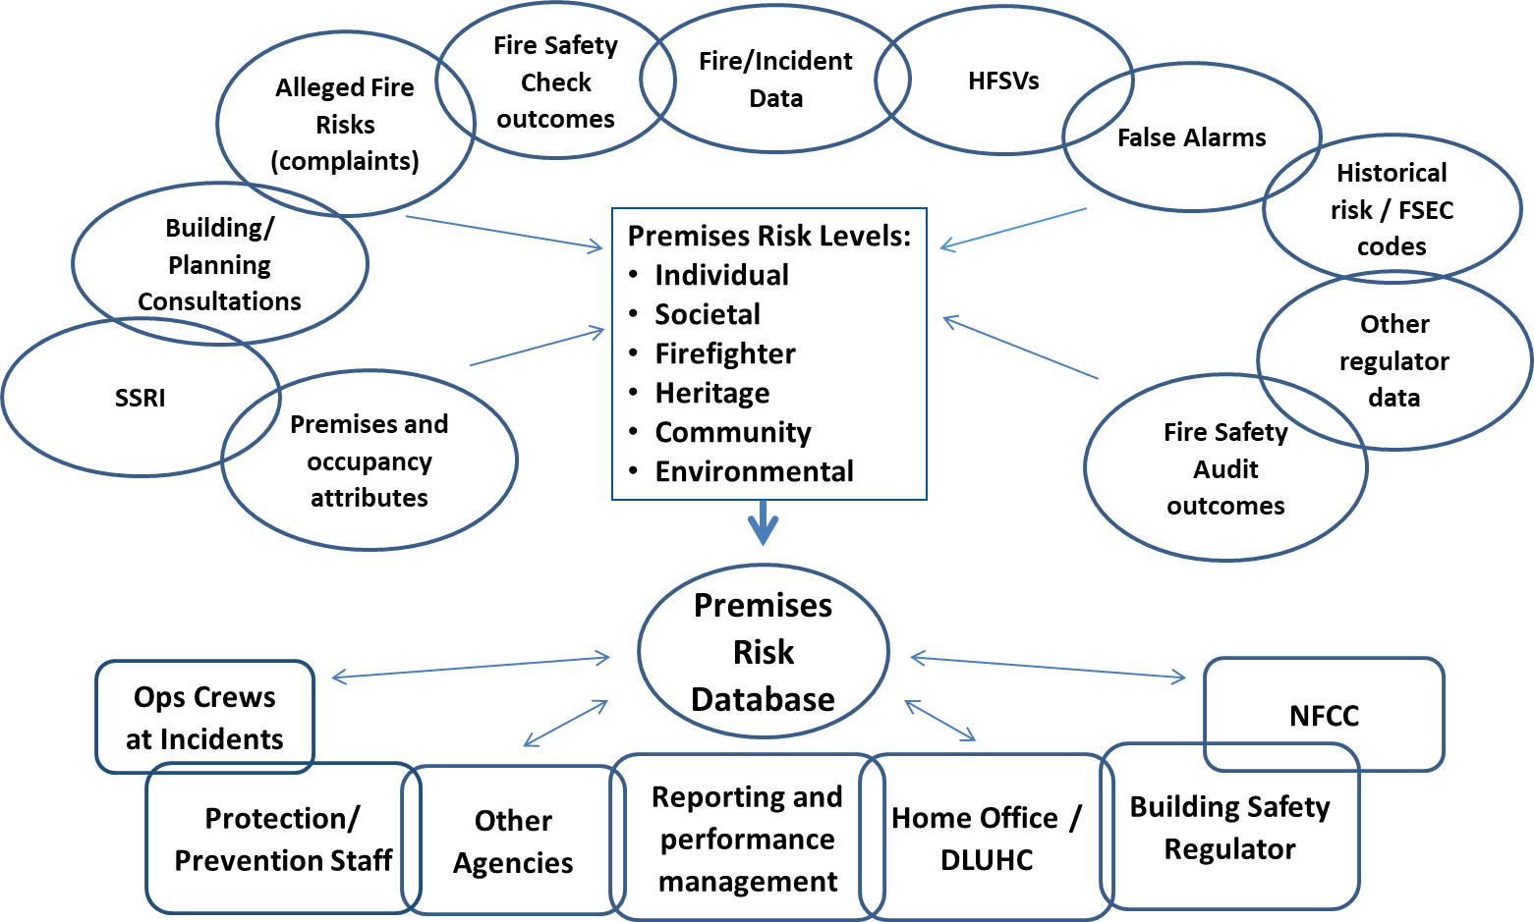

Principle of updating property databases to reflect modern built environment and occupancies
It is recognised that there are limitations to existing property databases and that alignment with Ordnance Survey data, IRS and other databases will provide greater consistency. Work is ongoing by NFCC in collaboration with the Home Office on each of these to support FRS in future.
FRS may find that local authorities and CQC databases may be able to support them to identify specific occupancy types that may not currently be identified on their existing property databases but which are classified among the highest risk occupancies within this guidance. Examples of these are:
- Sheltered and extra care sheltered flats
- Supported Living (Flats or bedsits)
- Hostels and refuges

There is also a range of additional information about buildings or occupiers that would add to the risk profile of premises on FRS property databases. Examples of these are:
- New building risk factors required – eg timber frame, modern methods of construction, external wall systems etc
- New occupancy risk factors required – Simple evacuation, complex evacuation (progressive, phased etc), sleeping dependent

Appendix 2
Risk Groups
Individual Fire Risk reduction
Individual Fire Risk is the potential for the death or injury of an individual or small group within a single fire compartment eg occupants of a flat, house. Fire risk is predominantly reduced through Prevention interventions and further actions such as adult at risk/ safeguarding referrals.
In the FRS context, community safety activities are primarily based on education or prevention programmes such as Home Fire Safety Visits, which aim to influence human behaviour to prevent fires from occurring in dwellings or to protect people in the event that they do occur. Community Safety activities may be complemented by Fire Safety (Structural Protection/ Enforcement) activities in multi occupied buildings with common parts and Operational (Intervention/Response) arrangements. Together, the risk to the community will be reduced through the effective combination of prevention, protection and response means.
Societal Life Fire Risk Reduction
Societal Life Fire Risk is a commonly understood term originally established in the FSEC tools and IRMP Guidance Note 4 (GN4). It is the potential for the death or injury of multiple individuals or groups in multiple compartments due to fire spreading before individuals can evacuate the building.
In this category compliance with the Fire Safety Order is also relevant and risk interventions include the ‘risk-based inspection programmes’ (GN4) carried out by both Protection or Response staff.
An effective ‘risk-based inspection programme’ relies on the prioritisation of specific building types or occupancies so that the highest risk or more complex premises are prioritised for physical inspections by competent inspecting officers. Fire safety advisors and operational crews can carry out fire safety checks on less complex occupancies. The competency of the staff inspecting or checking buildings is defined by the National Competency Framework for Fire Safety Regulators.
The highest priorities for physical inspections are likely to be defined by the nature of the occupancy and their ability to respond to a fire in the premises. For example, high dependency occupants who require/rely on assistance to escape from the premises to a place of safety will likely be the highest priority for inspection.
Firefighter Risk Reduction
Firefighter Fire Risk is the potential for the death or injury of a firefighter due to:
- the hazardous items or processes contained within a premises,
- complex layout
- or where firefighters are unable to use their normal safe systems of work and require an adapted tactical firefighting plan for the premises.

Fire and Rescue Service Operational Guidance – Operational Risk Information outlines the Provision of Operational Risk Information System (PORIS) methodology in gathering information about risk. Section 7(2)(d) of the Fire and Rescue Services Act 2004 places a responsibility on the Fire and Rescue Authority to make arrangements for obtaining information needed for that purpose and making it readily available to operational crews. Fire and Rescue Services already capture data and information to support the core functions of their organisations, such as: operations, fire safety, emergency planning, fire investigations, health and safety, incident debriefs and reports, etc. Fire and Rescue Services vary in the extent of the data collected and held and the policies and processes related to the use, storage and dissemination of this data and information. However, data and information may be stored in isolation and the consequent data integration issues may affect efficient operational pre-planning and incident management.
To assist the Fire and Rescue Service to meet their statutory duties and responsibilities in relation to operational risk information, the guidance introduces a model approach. The PORIS model provides a strategic framework that is compatible with other relevant data and information systems such as the Incident Recording System, Fire Service Emergency Cover (FSEC) Toolkit, generic risk assessments, fire safety data, and security guidance. The model provides a common methodology and approach to managing the identification, gathering, analysis, provision, audit and review of operational data, whilst allowing individual Fire and Rescue Services the flexibility to integrate its processes into their own systems.
Environmental Risk Reduction
Environmental Fire Risk is the potential for a fire in a building or on a site to negatively impact the environment in the immediate or wider vicinity of a premises through the involvement of environmental hazards in a fire or the firefighting interventions required to extinguish the fire eg foam, water, controlled burn.
IRMP Steering Group Integrated Risk Management Planning: Policy Guidance Environmental Protection (Link) gives guidance on the risk assessment of environmental hazards. FRSs attend incidents that have the potential to pollute air, land and water. Water courses and other aquatic environments are considered to be the most vulnerable to pollution from emergency incidents and the aspect of the environment that the FRS can protect most readily. The development of pollution prevention and control in all areas is, however, seen as a core function in an IRMP that is designed to improve the safety of the community.
Heritage Risk Reduction
Heritage Fire Risk is the potential for the partial or total loss of items, premises or sites of heritage value. The whole of our historic environment enriches our quality of life and contributes to local character and a sense of place; and are of special importance nationally or even internationally.
The main criteria used in selecting buildings to be listed are:
- architectural and/or historic interest: this includes buildings which illustrate important aspects of the nation’s social, economic, cultural or military history
- group value, especially where buildings comprise an important architectural or historic unity or are a fine example of planning (such as squares, terraces and model villages).

Community Risk Reduction
Community Fire Risk is the potential for a fire to create severe consequences on a local community or wider economy through loss of critical community assets. This may be linked to public risk perception, sense of wellbeing, mental health, financial position, loss of public services, social interaction, political and media impact etc. eg loss of a school or hospital.
The British Insurance Brokers Association (BIBA) report that Government figures suggest nearly 1 in 5 businesses suffer a major disruption every year and 80% of businesses affected by a major incident close down within 18 months. Such disruption does not only occur in the commercial sector; local authorities and other public and voluntary sector organisations can also be victims of a major fire incident. The consequential impact of such a major event can seriously effect the wider community, potentially for long term periods, and can be a contributory factor in increased levels of crime, unemployment, health and housing inequalities.
There is an objective within the national government guidance (IRMP) for ‘reducing the commercial, economic and social impact of fires and other emergency incidents’.

Appendix 3 – Summary of Relevant Legislation and Published Guidance

Document Title | Purpose
Regulatory Reform (Fire Safety) Order 2005 | Underpinning legislation
CFOA Fire Safety Guidance Notes and Audit | CFOA Guidance on the Audit process, including Short Audits
IRMP Guidance Note 4: A Risk Based Approach to Managing a Fire Safety Inspection Programme | Guidance on RBIPs – please note this document has now been archived
Fire and Rescue Services Act 2004 | Copy of the legislation
Fire and Rescue National Framework for England | Sets out Government priorities and objectives for FRSs
NFCC Competence Framework for Fire Safety Regulators | Outlines for qualification and maintenance of competency
Regulators’ Code | Lists provisions of the code

Community Risk Planning Guidance
Fire Standards
IRMP Guidance Note 4, Sep 2009
Fire & Rescue National Framework 2018
The Regulatory Reform (Fire Safety) Order 2005
Fire and Rescue Services Act 2004
https://www.ukfrs.com/fire-standards
https://www.gov.uk/government/consultations/reforming-our-fire-and-rescue-service
Fit for the Future, NFCC
COVID-19 Protection Risk Based Desktop Appraisal
Short Audits Guidance 2015
Short Audits Guidance 2015
http://www.cfoa.org.uk/21272
Data and Business Intelligence Guidance, NFCC
CRP Definition of Risk Project
Provision of Operational Risk Information System, Section 10

